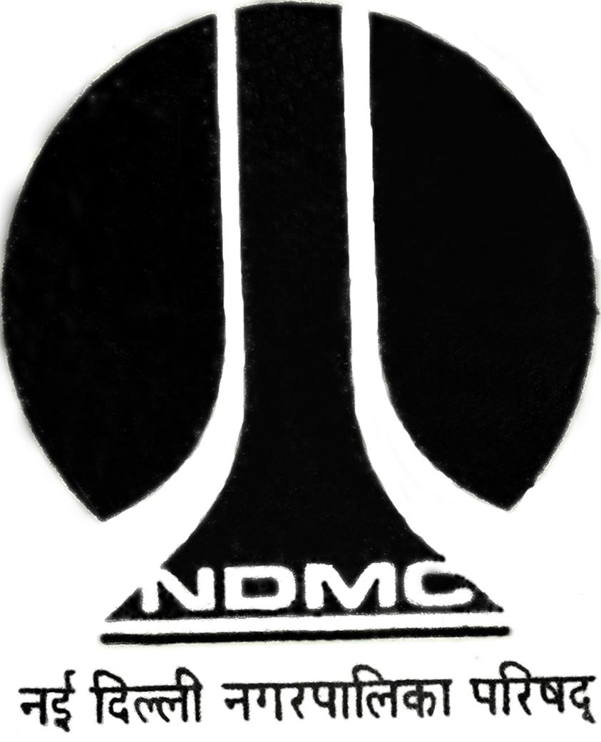
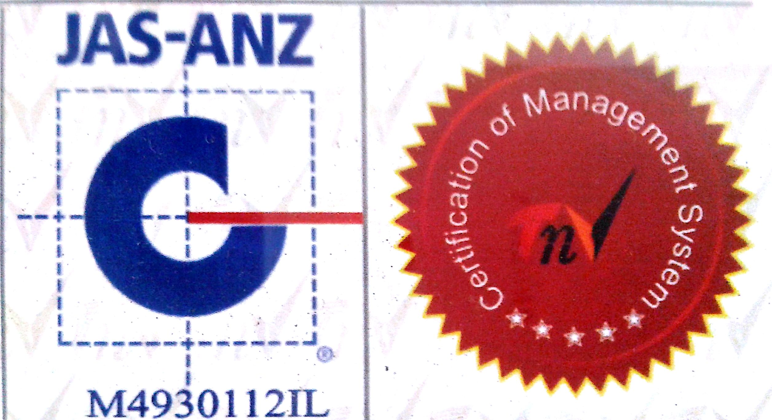
MTL/ FO/ 28 (c)

NEW DELHI MUNICIPAL COUNCIL

MATERIAL TESTING LABORATORY
QUALITY CONTROL CELL
VIDYUT BHAWAN, NEW DELHI
TEST REPORT OF BITUMEN EXTRACTION AND GRADATION

Name of Work :
Name of Agency :
- BITUMEN EXTRACTION TEST :
Type of Mix :
Wt. of Sample taken :
Wt. of aggregate after extraction :
Wt. of Bitumen :
% of Bitumen by wt. of Mix :

% of Bitumen as per job Mix formula :
- SIEVE ANALYSIS TEST

Wt. of Extracted / Fine Aggregate Finer than 2.36 mm =
Wt. of Bitumen =
Total Weight =

Composition of Mastic block without Coarse aggregate ( % by Wt.)

Passing  I.S. Sieve | Retained  I.S. Sieve | Wt. of Retained (gm) | % of Retained | Limit as Per Job mix formula
Bitumen |  |  |  | 14 % -- 17 %
2.36 mm |  |  |  | 00 % -- 22 %
600 μ |  |  |  | 04 % -- 30 %
212 μ |  |  |  | 08 % -- 18 %
75 μ |  |  |  | 25 % -- 45 %
 | Total Weight

A.E. (Lab) E.E. (Q.C.& T.A) -I

