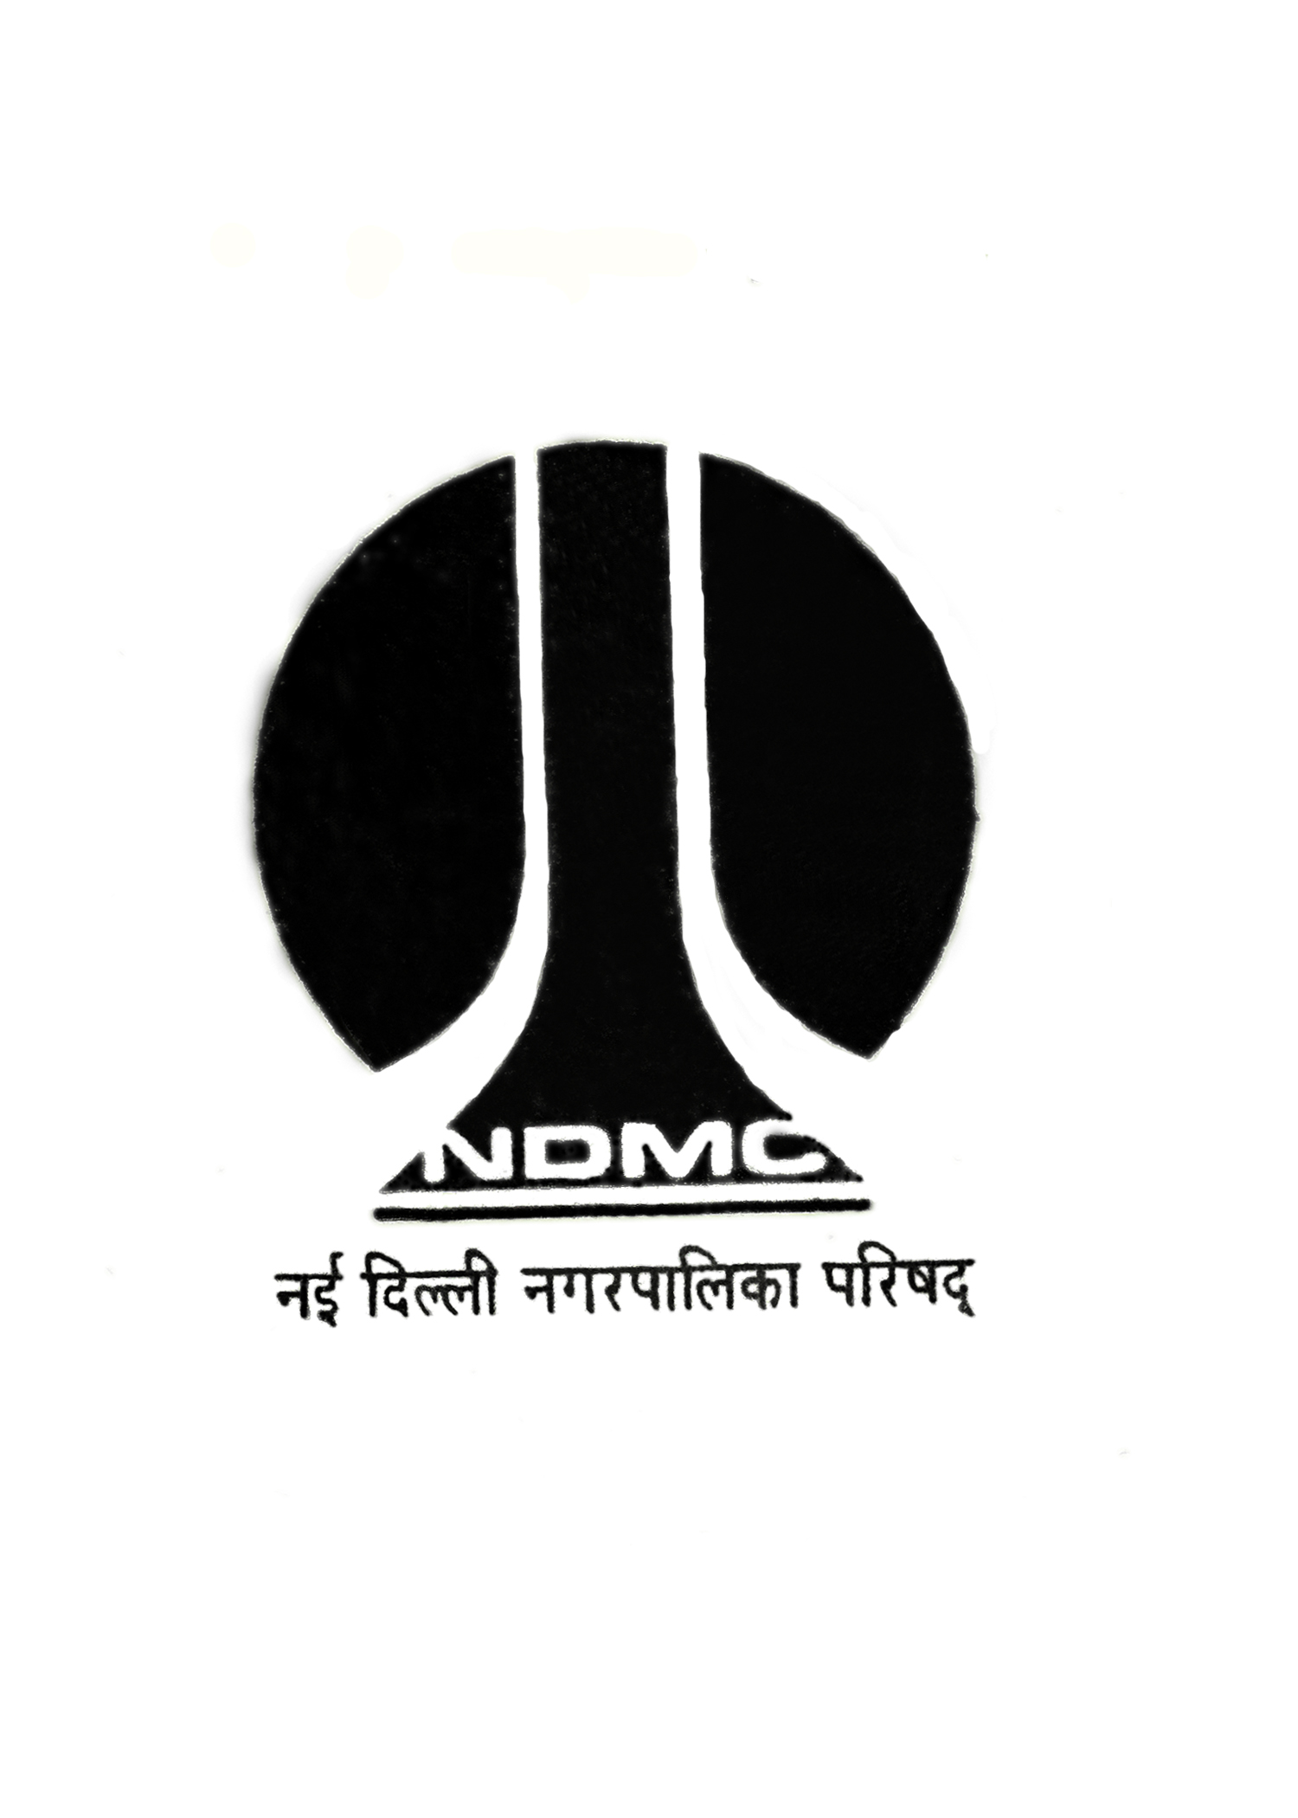
MTL/FO/26A 
NEW DELHI MUNICIPAL COUNCIL
MATERIAL TESTING LABORATORY
QUALITY CONTROL CELL
VIDYUT BHAWAN, NEW DELHI

PROFORMA FOR CHEMICAL RESISTANCE TEST OF CERAMIC GLAZED TILES

- Name of Work & Site :

2. Name of Division :

3. Name of Agency :

4. Name of Executive Engineer :

5. Name of Assistant Engineer :

6. Name of Junior Engineer :

7. Size of Tiles :

8. No. of Samples :

9. Mark / Make of Tiles :

10. Colour of Tiles :

11. Remarks :

J.E. (Work) Contractor A.E. (Work) E.E ( )

Sr. No | Properties | Observation | Class | Result
1. | Resistance to Staining (Methylene Blue & Potassium Permagnate)
2. | Resistance to Household Chemicals, Swimming Pool, Salts and Citric Acid (Ammonium Chloride, Sodium Hypochlorite, Copper Sulphate)

AE (Lab) EE (QC&TA)-I)

