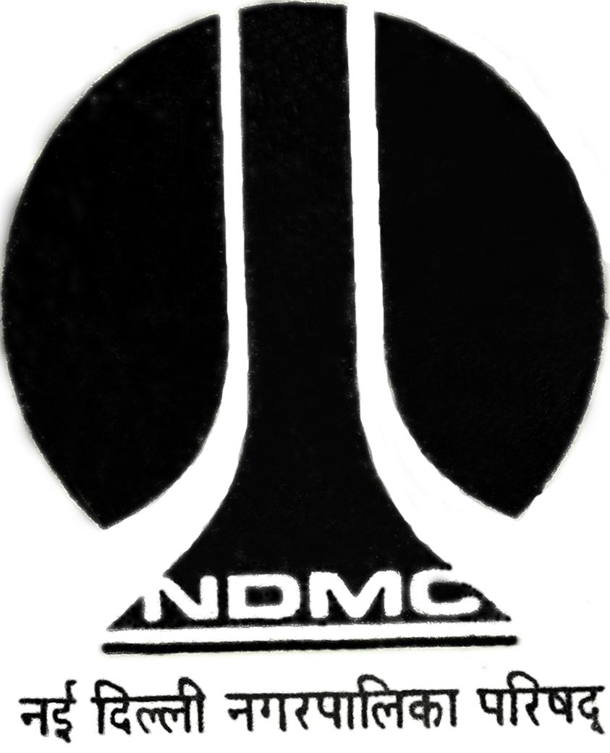
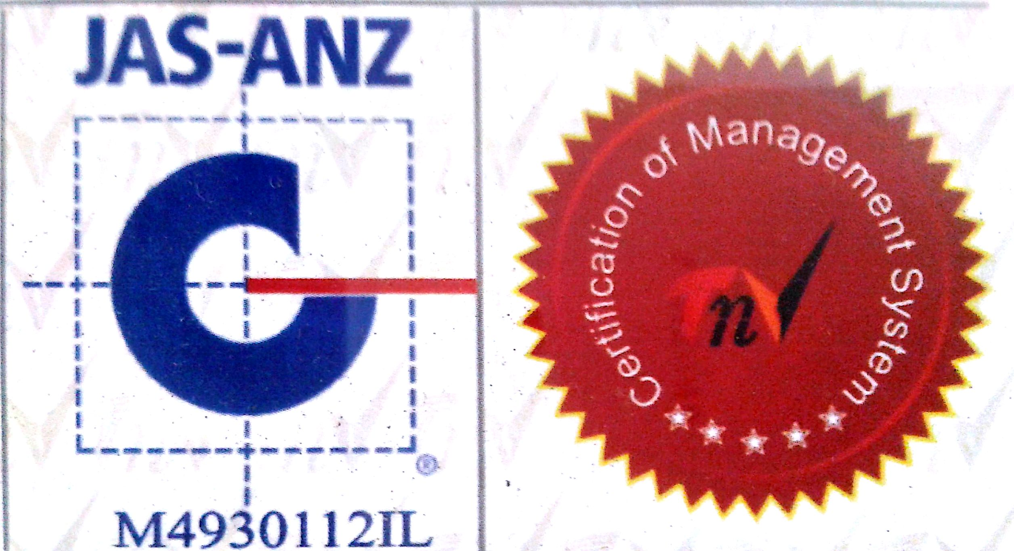

MTL/ FO/ 26B
NEW DELHI MUNICIPAL COUNCIL
MATERIAL TESTING LABORATORY
QUALITY CONTROL CELL
VIDYUT BHAWAN, NEW DELHI

PROFORMA FOR CHEMICAL RESISTANCE TEST OF VITRIFIED FLOOR TILES

- Name of Work :-

- Name of Division :-
- Name of Agency :-
- Name of Executive Engineer :-
- Name of Assistant Engineer :-
- Name of Junior Engineer :-
- Size of Tiles :-
- No. of Sample :-
9. 9. Mark/ Make of Tiles :-
10. 10. Colour of Tiles :-
11. 11. Remarks :-

J.E. (Work) Contractor A.E.( ) E.E.( )
Test Results
Sr.No. | Properties | Observation | Result
1. | Resistance to Household Chemicals, Swimming Pool, Salts and Citric Acid (Ammonium Chloride, Sodium Hypochlorite, Copper Sulphate)
2. | Resistance to Acids and Alkalis (with exception of hydrofluoric acid & its compounds).  Sulphuric acid, lactic acid & Potassium hydroxide solution.

A.E. (Lab.) E.E. (Q.C. & T.A.)-I

