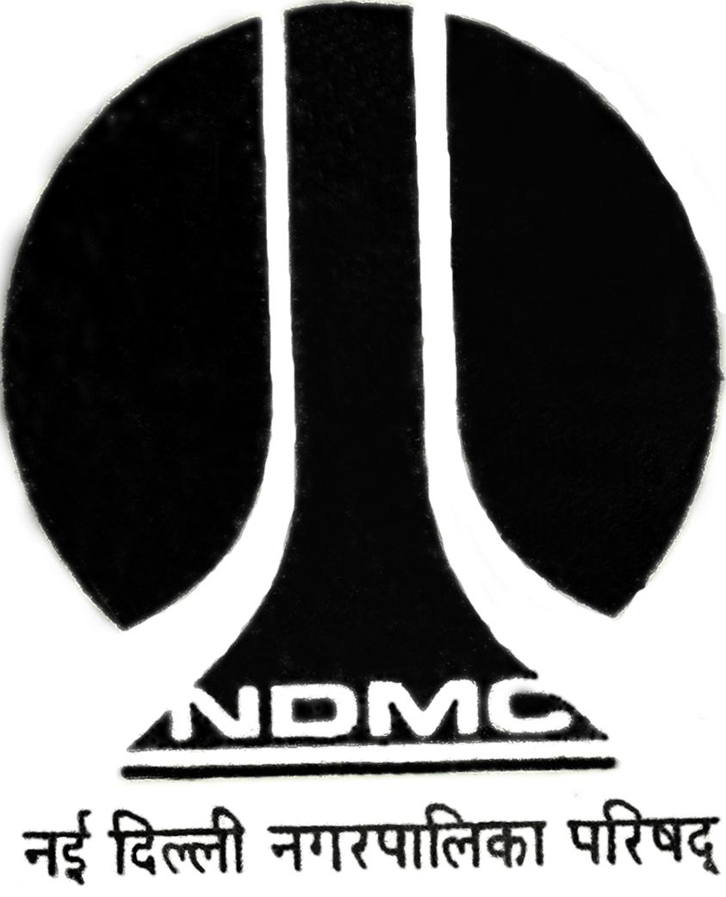
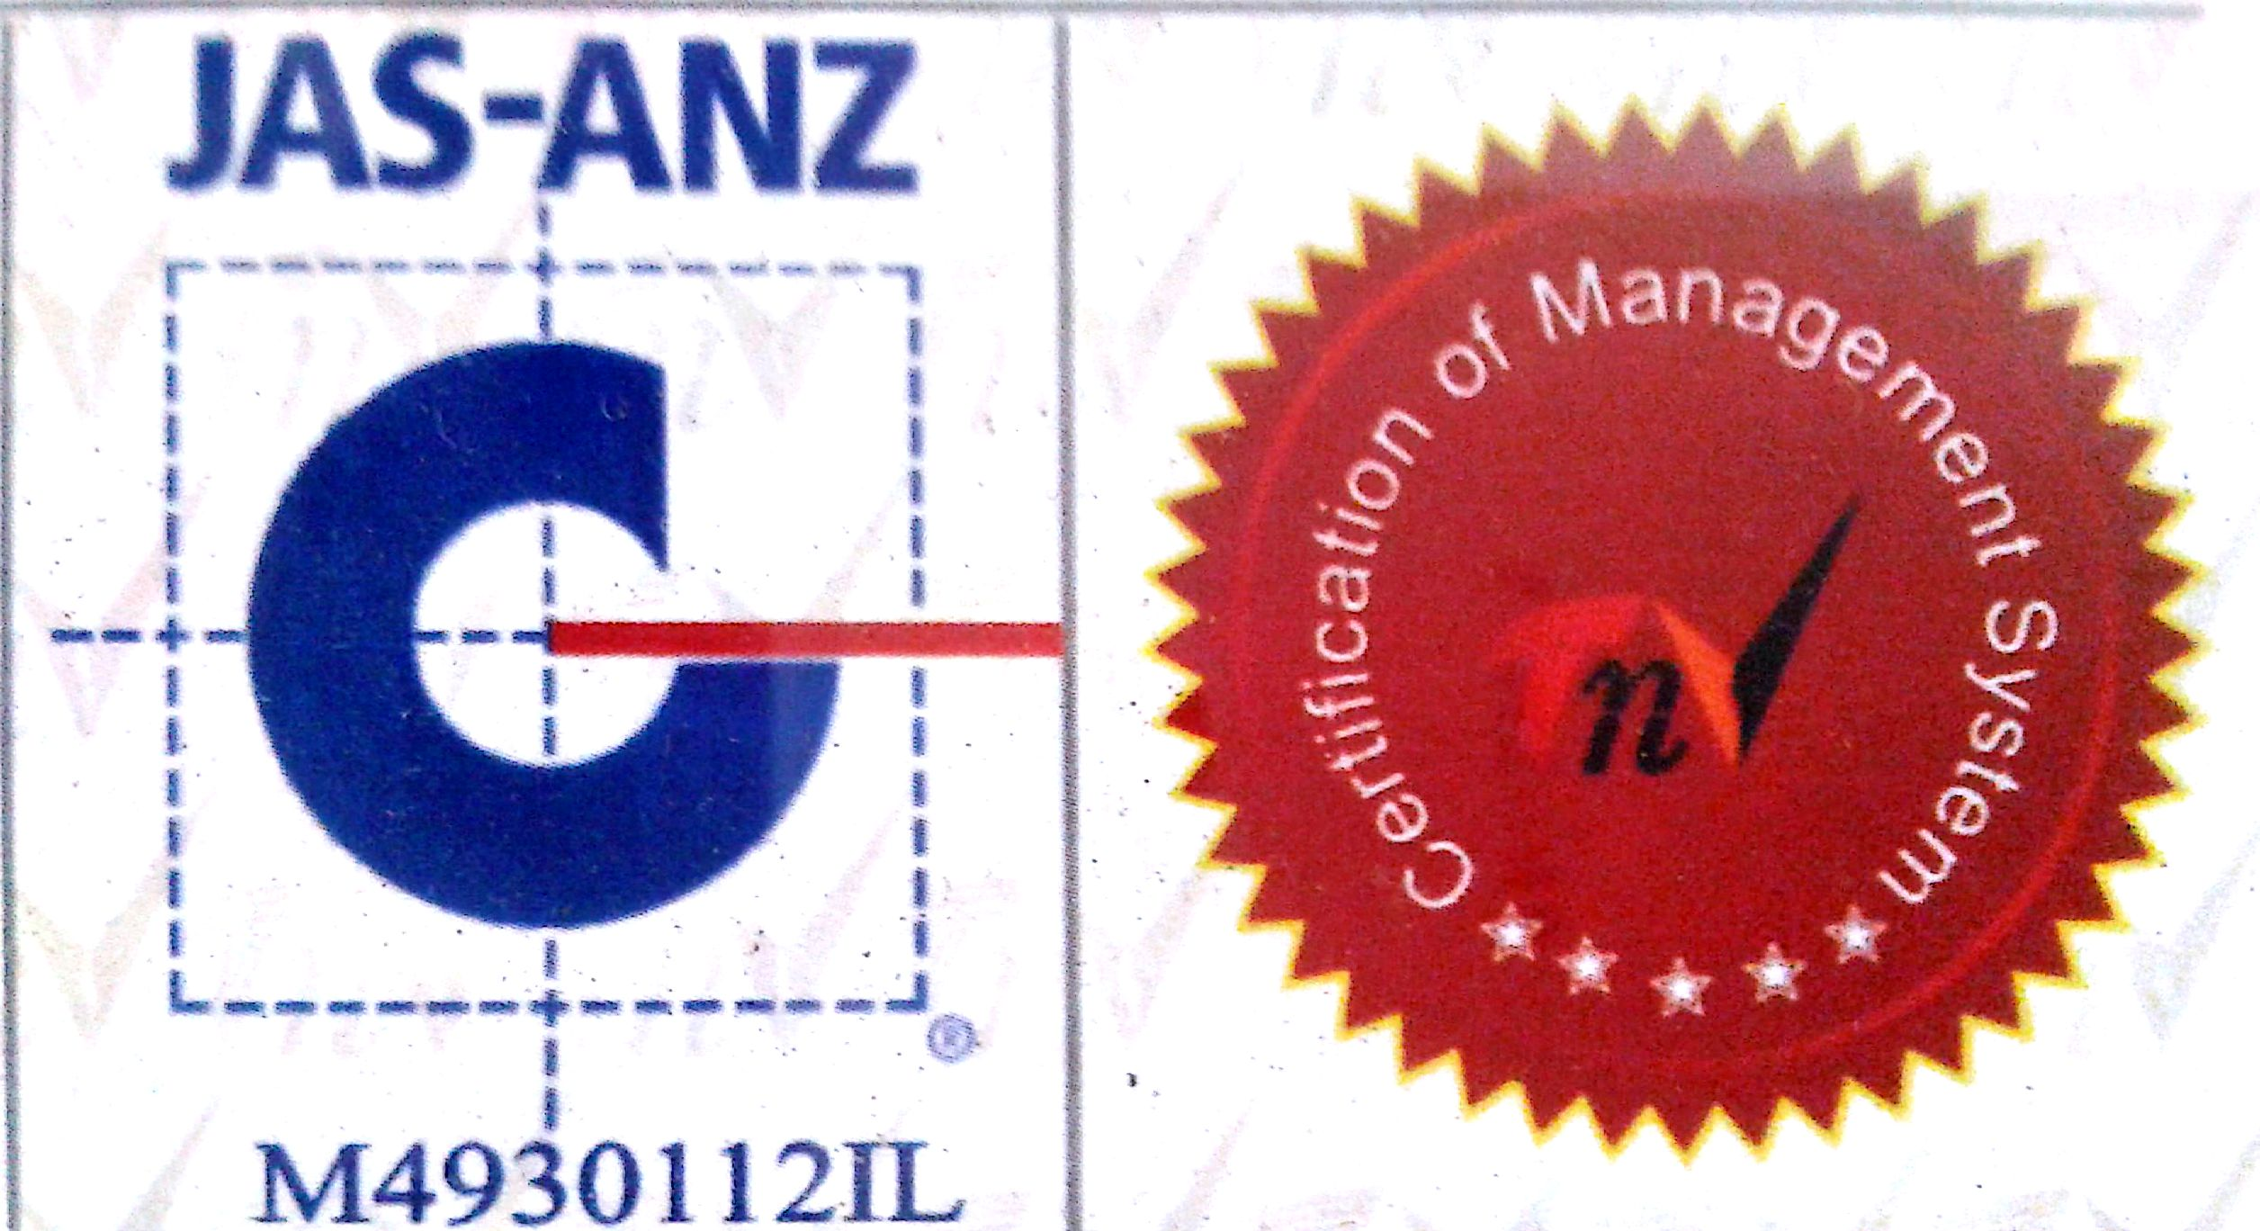

MTL / FO / 12-A

NEW DELHI MUNICIPAL COUNCIL

MATERIAL TESTING LABORATORY
QUALITY CONTROL CELL
VIDYUT BHAWAN, NEW DELHI

PROFORMA FOR AGGREGATE CRUSHING VALUE

- Name of Work :
2. Details from where sample is collected :
3. Name of Agency :
4. Name of Division :
5. Name of Executive Engineer :
6. Name of Assistant Engineer :
7. Name of Junior Engineer :
8. Size of the aggregate :
9. No. of samples :
10. Remarks :
11. Quantity of material represented by Sample :

Signature of Signature of Signature of. Signature of E.E.( )
J.E.(Work) Contractor A.E.( )

CALCULATION AND RESULTS

Particulars | Sample No. 1 | Sample No.2
Wt. of Sample taken (A) | - gms.  - gms. | (1) gms.  (2) gms.
Wt. of the fraction passing through 2.36mm I.S. Sieve (B) | (1) gms.  (2) gms. | (1) gms.  (2) gms.
Aggregate crushing value (B X 100)  A | - %  - % | (1). %  (2). %
Average Crushing Value | % | %

A.E.(Lab.) EE(QC&TA-I)

