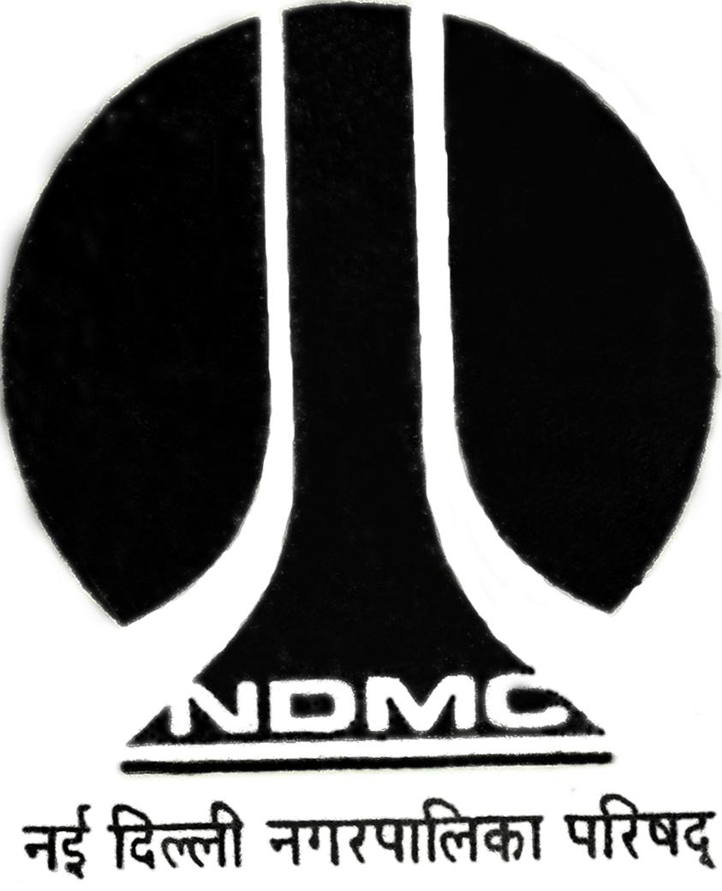
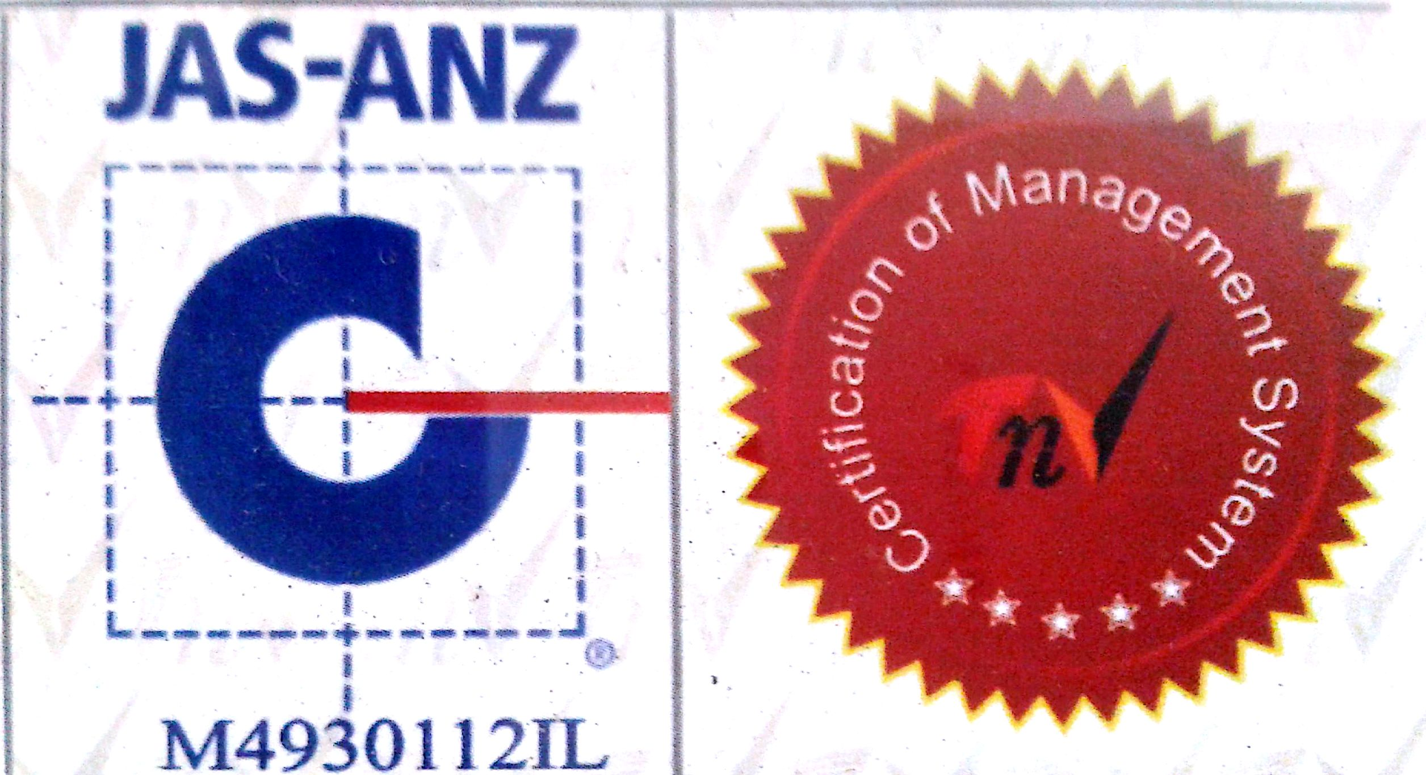
MTL/ FO/ 35
NEW DELHI MUNICIPAL COUNCIL
MATERIAL TESTING LABORATORY
QUALITY CONTROL CELL
VIDYUT BHAWAN, NEW DELHI

PROFORMA FOR WATER ABSORPTION TEST FOR STONE / STONE AGGREGATE / C.C.PREFEB ITEMS

- Name of Work :-

- Details from where sample is collected :-
- Name of Agency :-
- Name of Division :-
- Name of Executive Engineer :-
- Name of Assistant Engineer :-
- Name of Junior Engineer :-
- No. of Specimens :-
- Mark on Specimen, if any :-
- Size of Specimens :-
- Colour of Specimens :-
- Remarks :- Sample represents…………….

Sig. of J.E. ( ) Sig. of Contractor Sig. of A.E. ( ) Sig. of E.E. ( )
RESULT OF TEST

S.No. | Wt.(in gm.) of  The Saturated specimen (w₁) | Wt.(in gm.) of  the oven dried  Specimen (w₂) | Loss in Wt.(in gm.)  (w_{1 –}w₂) | Water absorption  % by wt.  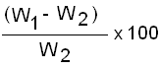
1.
2.
3.
4.
5.
6.

Average Water absorption………………….% (After 24 Hrs.)

A.E. (Lab.) E.E.(Q.C.& T.A.)-I

