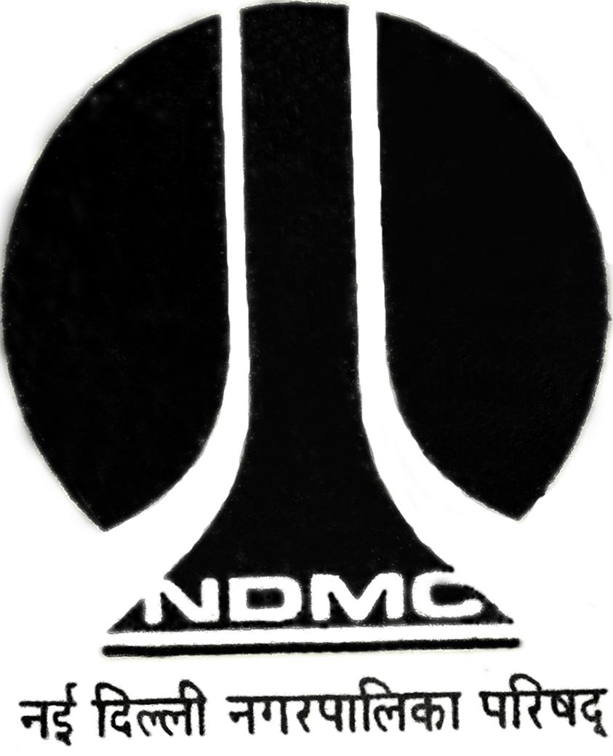

MTL/ FO/ 27(b)

NEW DELHI MUNICIPAL COUNCIL
MATERIAL TESTING LABORATORY
QUALITY CONTROL CELL
VIDYUT BHAWAN, NEW DELHI
DENSITY TEST RESULTS OF BITUMINOUS MIX CORE

Name of work :

Division :

Type / Nature of Sample :

Date of Test :

(A) Location of the Sample

Wt. of Sample in Air (W₁) : gm

Wt. of Sample With coat of Paraffin Wax in Air (W₂) : gm

Wt. of Sample in water (With / Without coat of Paraffin wax) (W₃) : gm

Volume of Bituminous Core (V) = W₁ – W₃ or W_{2 –} W₃ : gm or c.c

Wt. of Wax (W_{2 –} W₁) : gm

Density of Core of Bituminous Mix = Mass/ Volume : gm / c.c
W₁ / V or

(B) Location of the Sample

Wt. of Sample in Air (W₁) : gm

Wt. of Sample With coat of Paraffin Wax in Air (W₂) : gm

Wt. of Sample in water (With / Without coat of Paraffin wax) (W₃) : gm

Volume of Bituminous Core (V) = W₁ – W₃ or W_{2 –} W₃ : gm or c.c

Wt. of Wax (W_{2 –} W₁) : gm

Density of Core of Bituminous Mix = Mass/ Volume : gm / c.c
W₁ / V or

A.E.(Lab.) E.E.(QC & TA)- I

