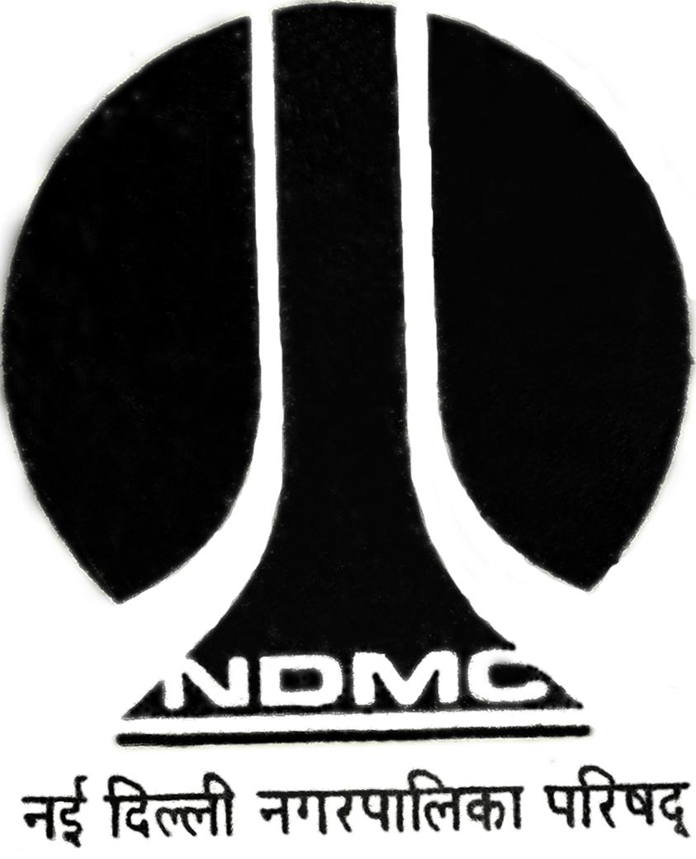
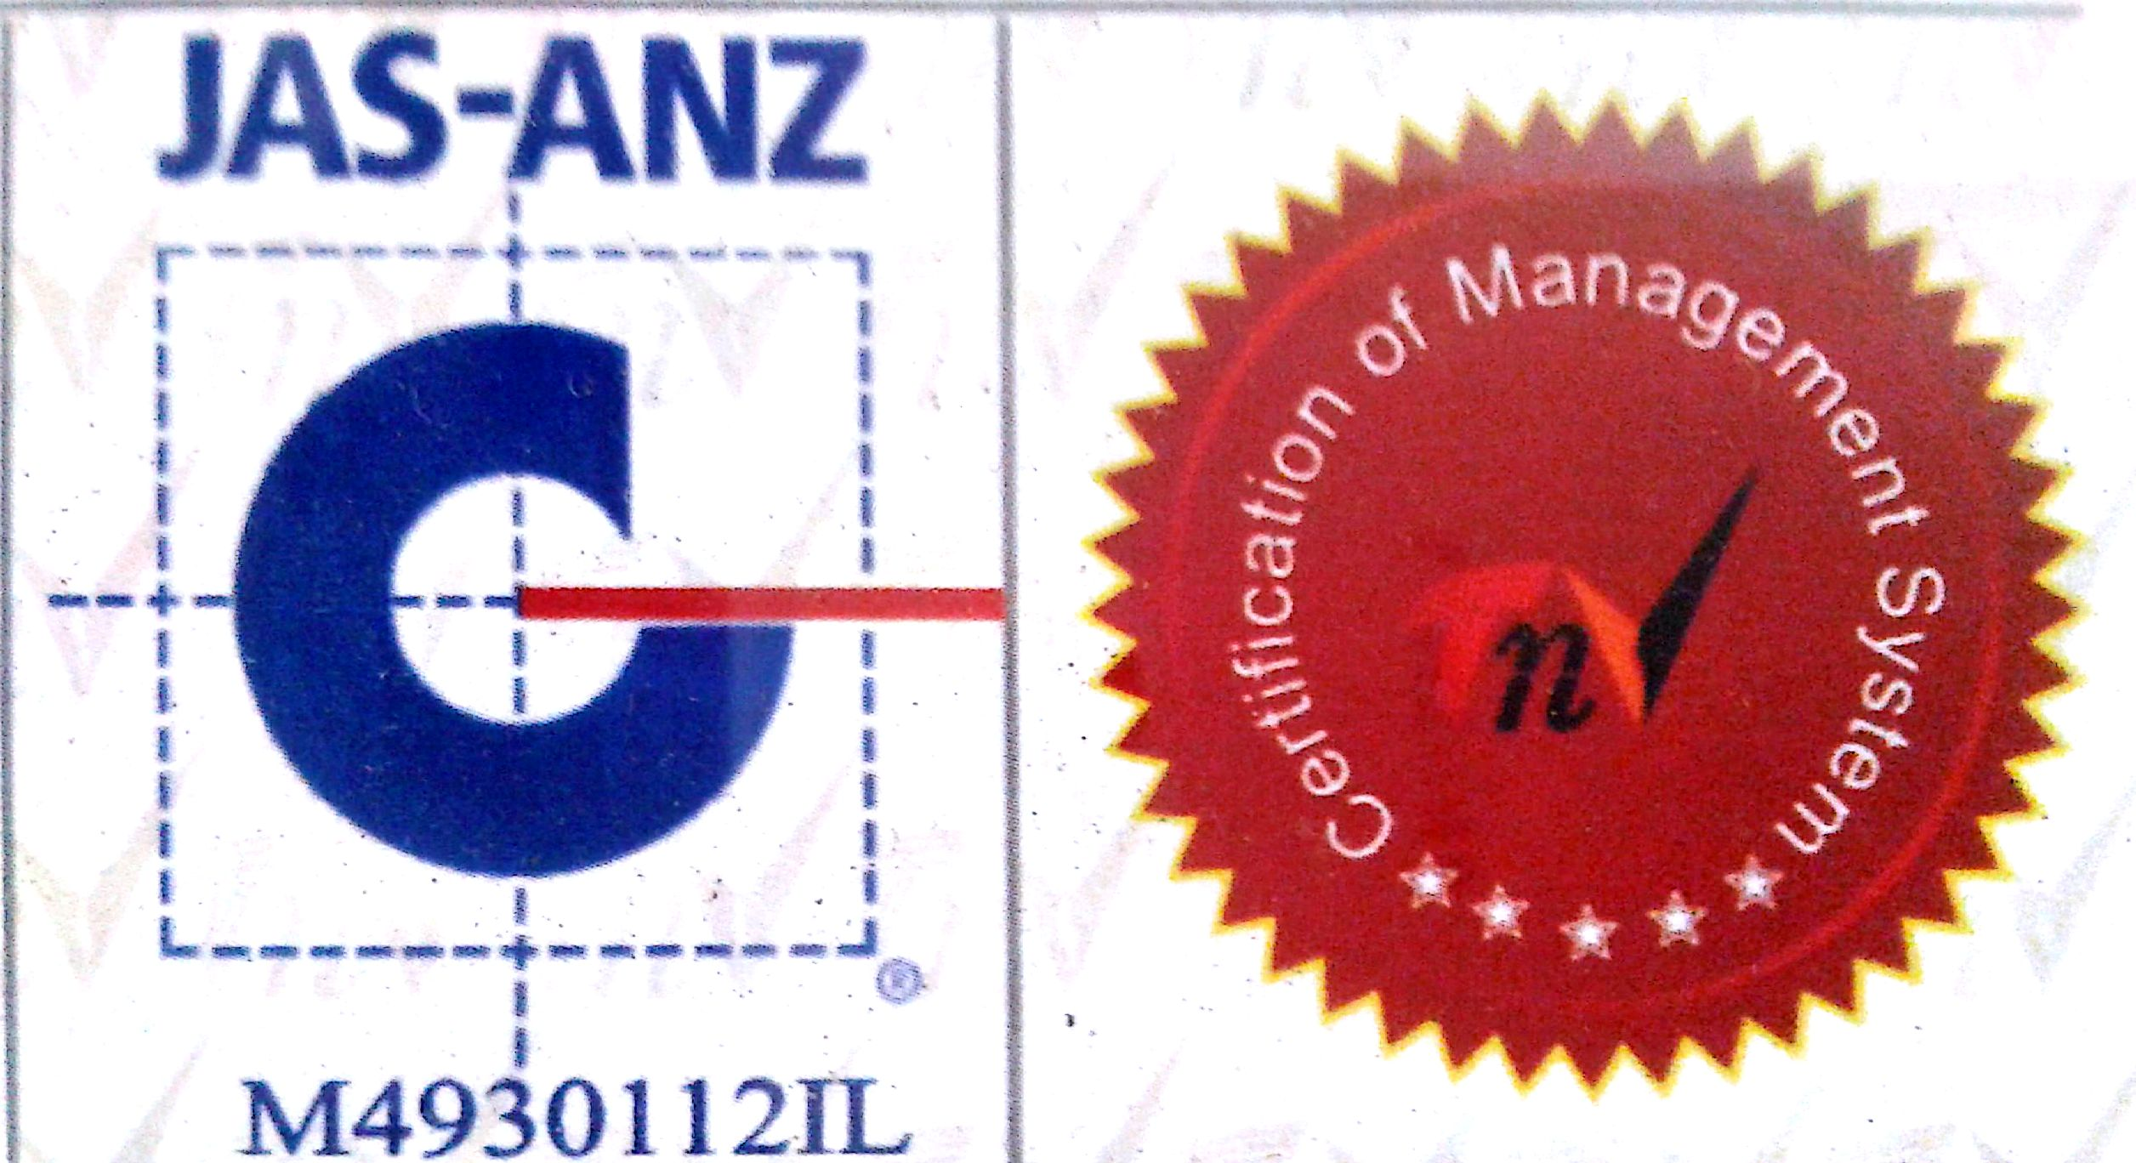
MTL/ FO/ 21
NEW DELHI MUNICIPAL COUNCIL

MATERIAL TESTING LABORATORY
QUALITY CONTROL CELL
VIDYUT BHAWAN, NEW DELHI
PROFORMA FOR WATER ABSORPTION TEST FOR C.C. TILES
1. Name of Work :-
2. Details from where sample is collected :-
3. Name of Agency :-
4. Name of Division :-
5. Name of Executive Engineer :-
6. Name of Asstt. Engineer :-
7. Name of Junior Engineer :-
8. Name of Contractor :-
9. No. of Specimens :-
10. Mark on Specimen, if any :-
11. Size of Specimens :-
12. Colour of Specimen :-
13. Remarks :- Sample represents………………Qty.

Sig. of J.E.( ) Sig. of Contractor Sig. of A.E. ( ) Sig. of E.E.( )

RESULT OF TEST

Sr. No. | Wt.(in gms) of the saturated specimen(W₁) | Wt.(in gms) of the oven dried specimen(W₂) | Loss in Wt.(in gms) (W₁-W₂) | Water absorption % by wt.  (W₁ - W₂) ×100  W₂ | Average water absorption
1.
2.
3.
4.
5.
6.

A.E.(Lab.) E.E.(Q.C.& T.A.)-I

