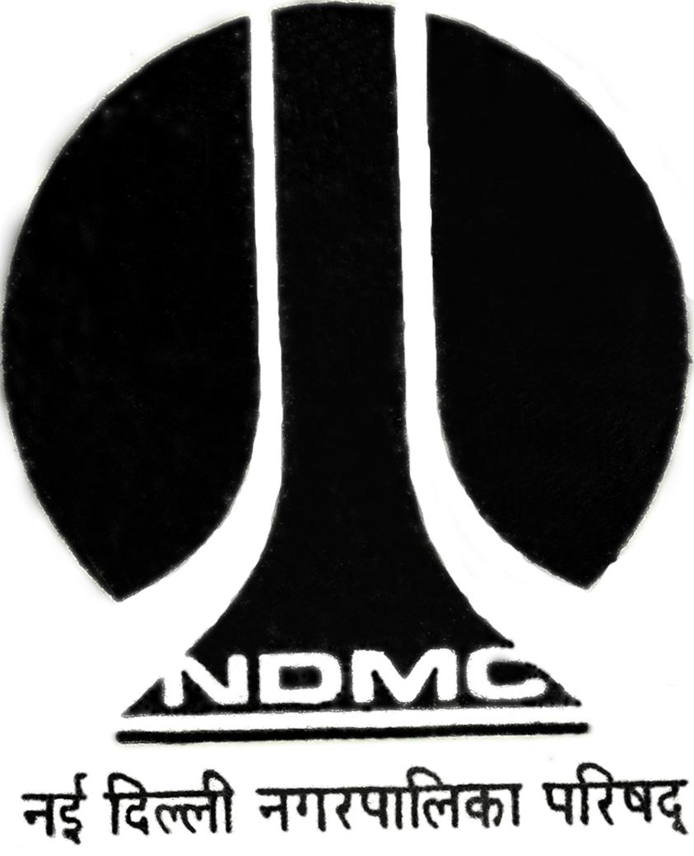
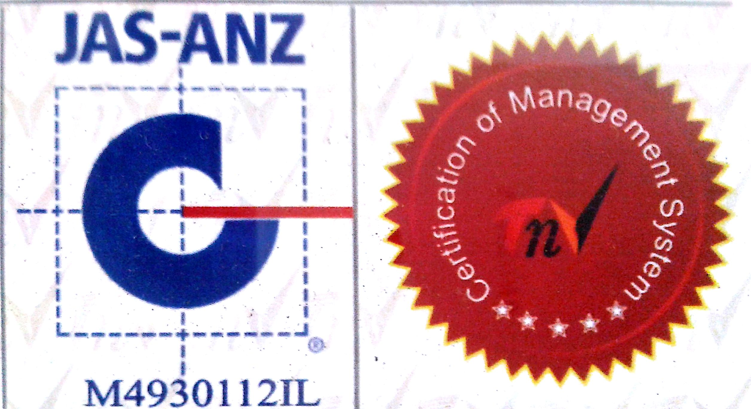
MTL/ FO/ 20
NEW DELHI MUNICIPAL COUNCIL
MATERIAL TESTING LABORATORY
QUALITY CONTROL CELL
VIDYUT BHAWAN, NEW DELHI

PROFORMA FOR “WET TRANSVERSE STRENGTH” OF PLAIN TILES / CC TILES
1. Name of work :-
2. Details from where sample collected :-
3. Name of Division :-
4. Name of Agency :-
5. Name of Executive Engineer :-
6. Name of Assistant Engineer :-
7. Name of Junior Engineer :-
8. Details of Sample C.C. Tiles / Terrazo Tile :-
9. Size of tiles :-
10.Thickness of Tiles :-
11. No. of Samples :- …….…..……..Nos.
12. Mark / Make of tiles :-
13. Colour of Tiles :-
14. Remarks :- Sample represent ………………. Qty

Sig. of J.E.( ) Sig. of Contractor Sig. of A.E. ( ) Sig. of E.E.( )
S.No | OBESERVATIONS |  |  |  | 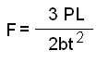 N/ mm² | Average Strength N/mm²
S.No | Tile Width  mm (b) | Span  mm (L) | Breaking  Load KN | Tile  Thickness (t) mm |  | Average Strength N/mm²
1
2
3
4
5
6

A.E.(Lab.) E.E.(Q.C.& T.A.)-I

