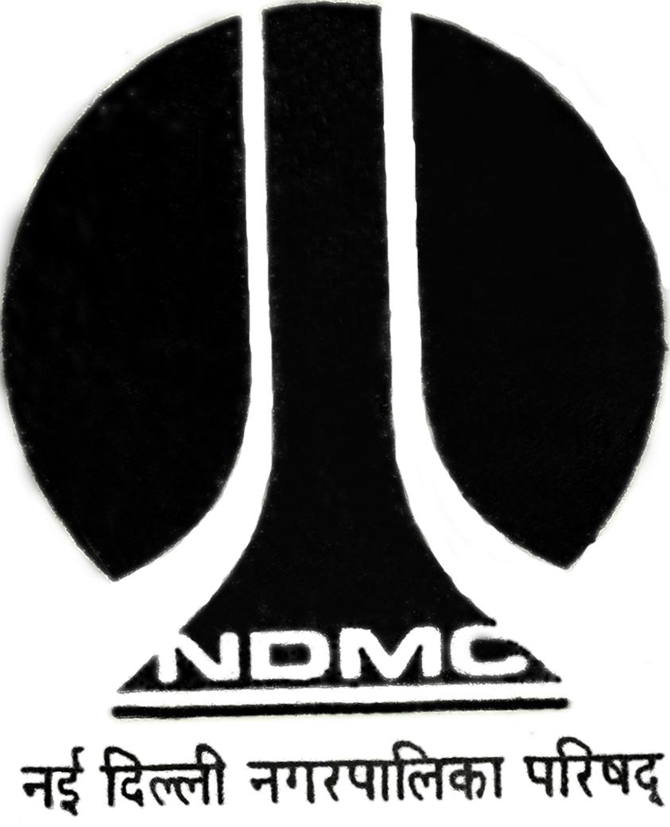
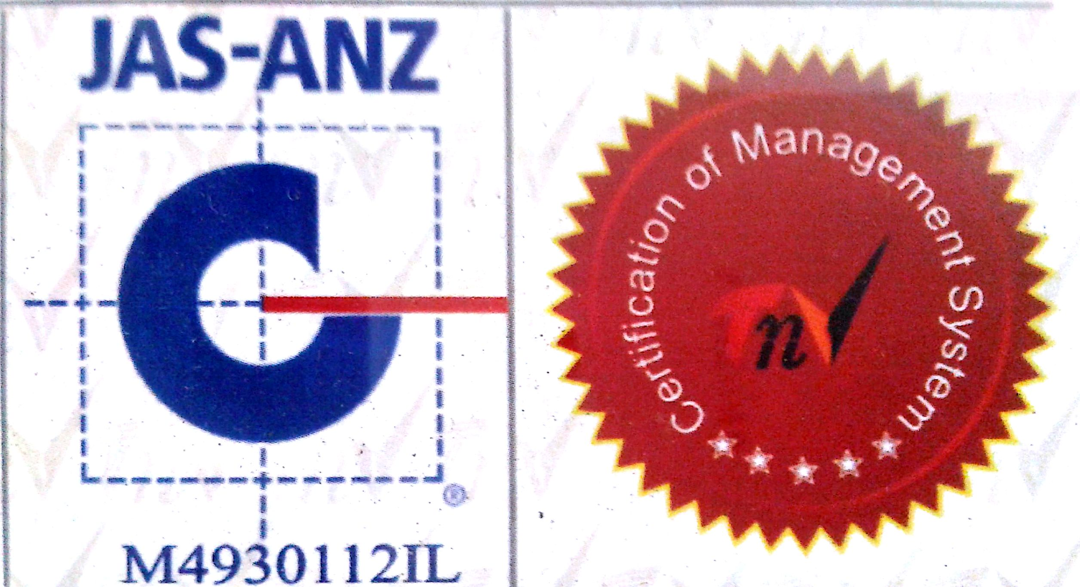

MTL/ FO/ 18
NEW DELHI MUNICIPAL COUNCIL

MATERIAL TESTING LABORATORY
QUALITY CONTROL CELL
VIDYUT BHAWAN, NEW DELHI
PROFORMA FOR WATER ABSORPTION TEST FOR BRICKS
- Name of Work :-
:-
- Details from where sample is collected :-

- Name of Agency :-

- Name of Division :-

- Name of Executive Engineer :-

- Name of Assistant Engineer :-

- Name of Junior Engineer :-

- No. of Specimens :-

- Mark on Specimen, if any :-

- Size of Specimens :-

- Colour of Specimens :-

- Premissible limit of water absorption :- Sample represent…………………..Qty
- Remarks :-
Sig. of J.E ( ) Sig. of Contractor Sig. of A.E. ( ) Sig. of E.E.( )
RESULT OF TEST

Mark | S.No | Wt.(in gms) of  The Saturated specimen (w₁) | Wt.(in gms) of  the oven dried  Specimen (w₂) | Loss in Wt.(in gms)  (w_{1 –}w₂) | Water absorption  % by wt.  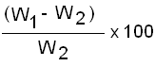
 | 1.
 | 2.
 | 3.
 | 4.
 | 5.

Average Water absorption………………………………….% (After 24 Hrs.)

A.E.(Lab.) E.E.(Q.C.& T.A.)-I

