
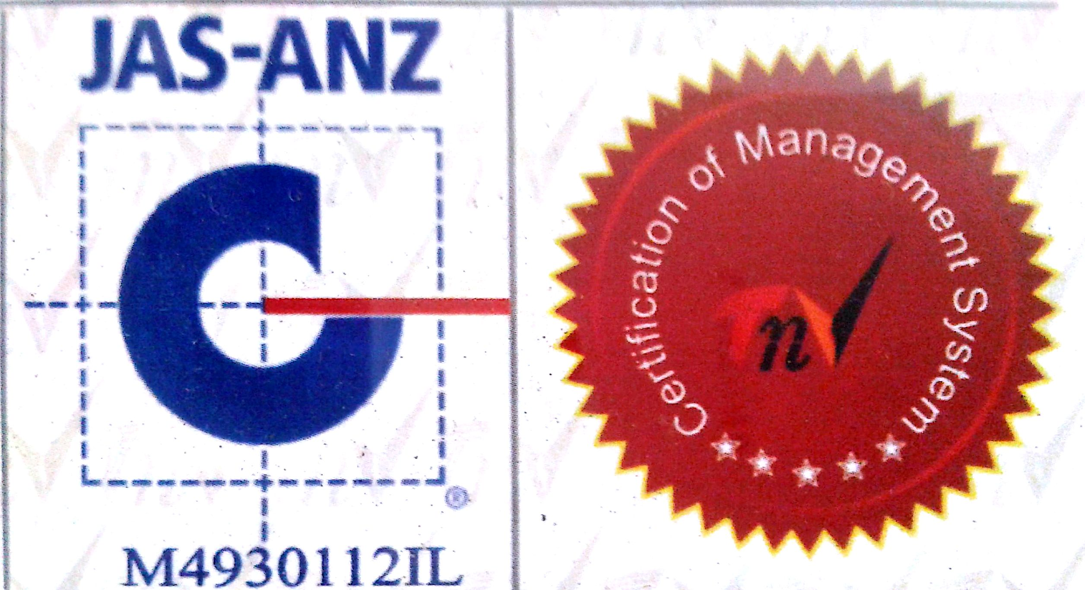

MTL/ FO/ 15
NEW DELHI MUNICIPAL COUNCIL

MATERIAL TESTING LABORATORY
QUALITY CONTROL CELL
VIDYUT BHAWAN, NEW DELHI
TEST REPORT OF SIEVE ANALYSIS OF FINE / COARSE AGGREGATE

1. Name of Work :-
:-
2. Agency :-
3. Date of receipt of Sample in Lab :-
4. Date of test :-
5. Weight of Sample for test :-
6. Sieve analysis for fine sand / coarse sand.
Sieve Size | Weight of Aggregate in gms. |  | % age Passing | Remarks Required Passing % age
Sieve Size | Retained | Passing | % age Passing | Remarks Required Passing % age
10 MM |  |  |  | 100 %
4.75 MM |  |  |  | 90 % to 100 %
2.36 MM |  |  |  | 85% to 100%
1.18 MM |  |  |  | 75% to 100%
600 Microns |  |  |  | 60% to 79%
300 Microns |  |  |  | 12% to 40%
150 Microns |  |  |  | 00% to 10%
PAN |  | ---- | ---- | ----

A.E.(Lab.) E.E.(Q.C.& T.A.)-I

