
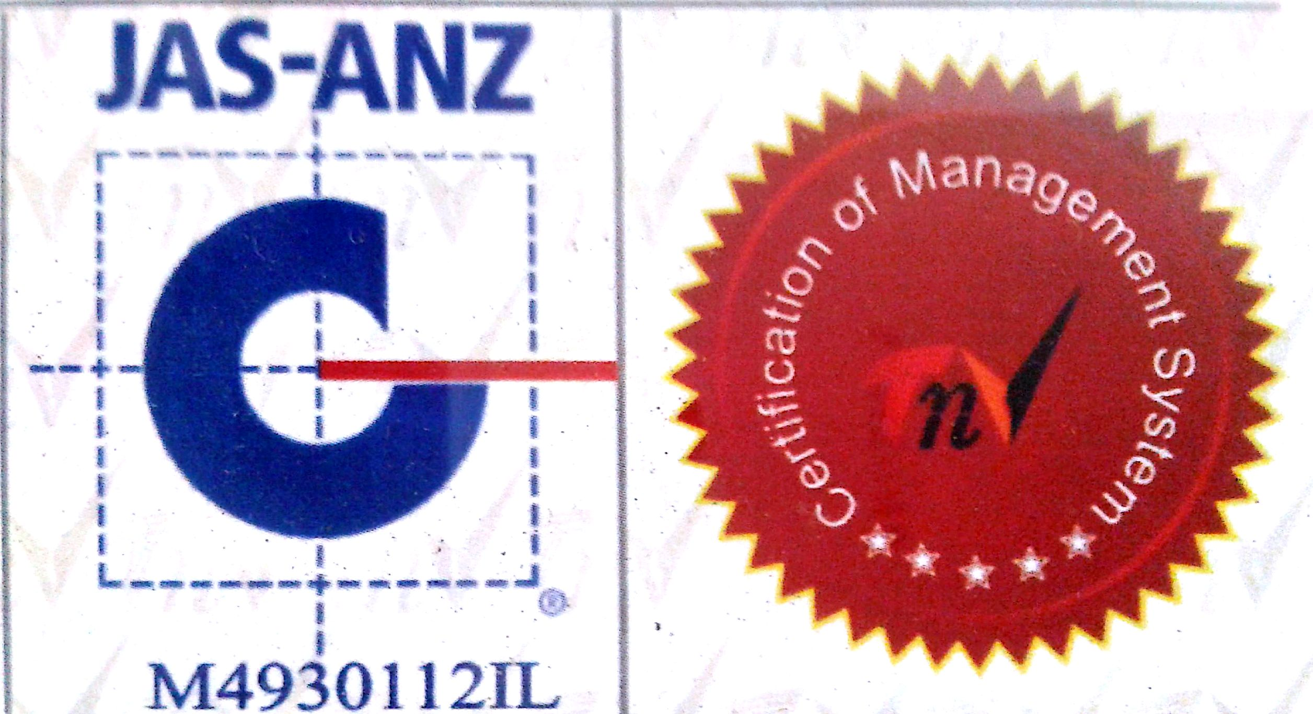

MTL/ FO/ 15
NEW DELHI MUNICIPAL COUNCIL

MATERIAL TESTING LABORATORY
QUALITY CONTROL CELL
VIDYUT BHAWAN, NEW DELHI
TEST REPORT OF SIEVE ANALYSIS

1. Name of Work________________________________________________________________________

2. Agency_____________________________________________________________________________
3. Date of receipt of Sample in Lab._________________________________________________________
4. Date of test__________________________________________________________________________
5. Weight of Sample for test______________________________________________________________
6. Sieve analysis for ____20 mm_______ Graded nominal Size aggregate.
Sieve Size  (mm) | Weight of Aggregate in gms. |  | % age Passing | Remarks  Required Passing % age
Sieve Size  (mm) | Retained | Passing | % age Passing | Remarks  Required Passing % age
40 mm |  |  |  | 100%
20 mm |  |  |  | 95% to 100%
10 mm |  |  |  | 25% to 55%
4.75 mm |  |  |  | 00% to 10%
PAN |  | ------------ | ------------ | ------------

A.E. ( Lab.) E.E.( Q.C.& T.A.)-I

