
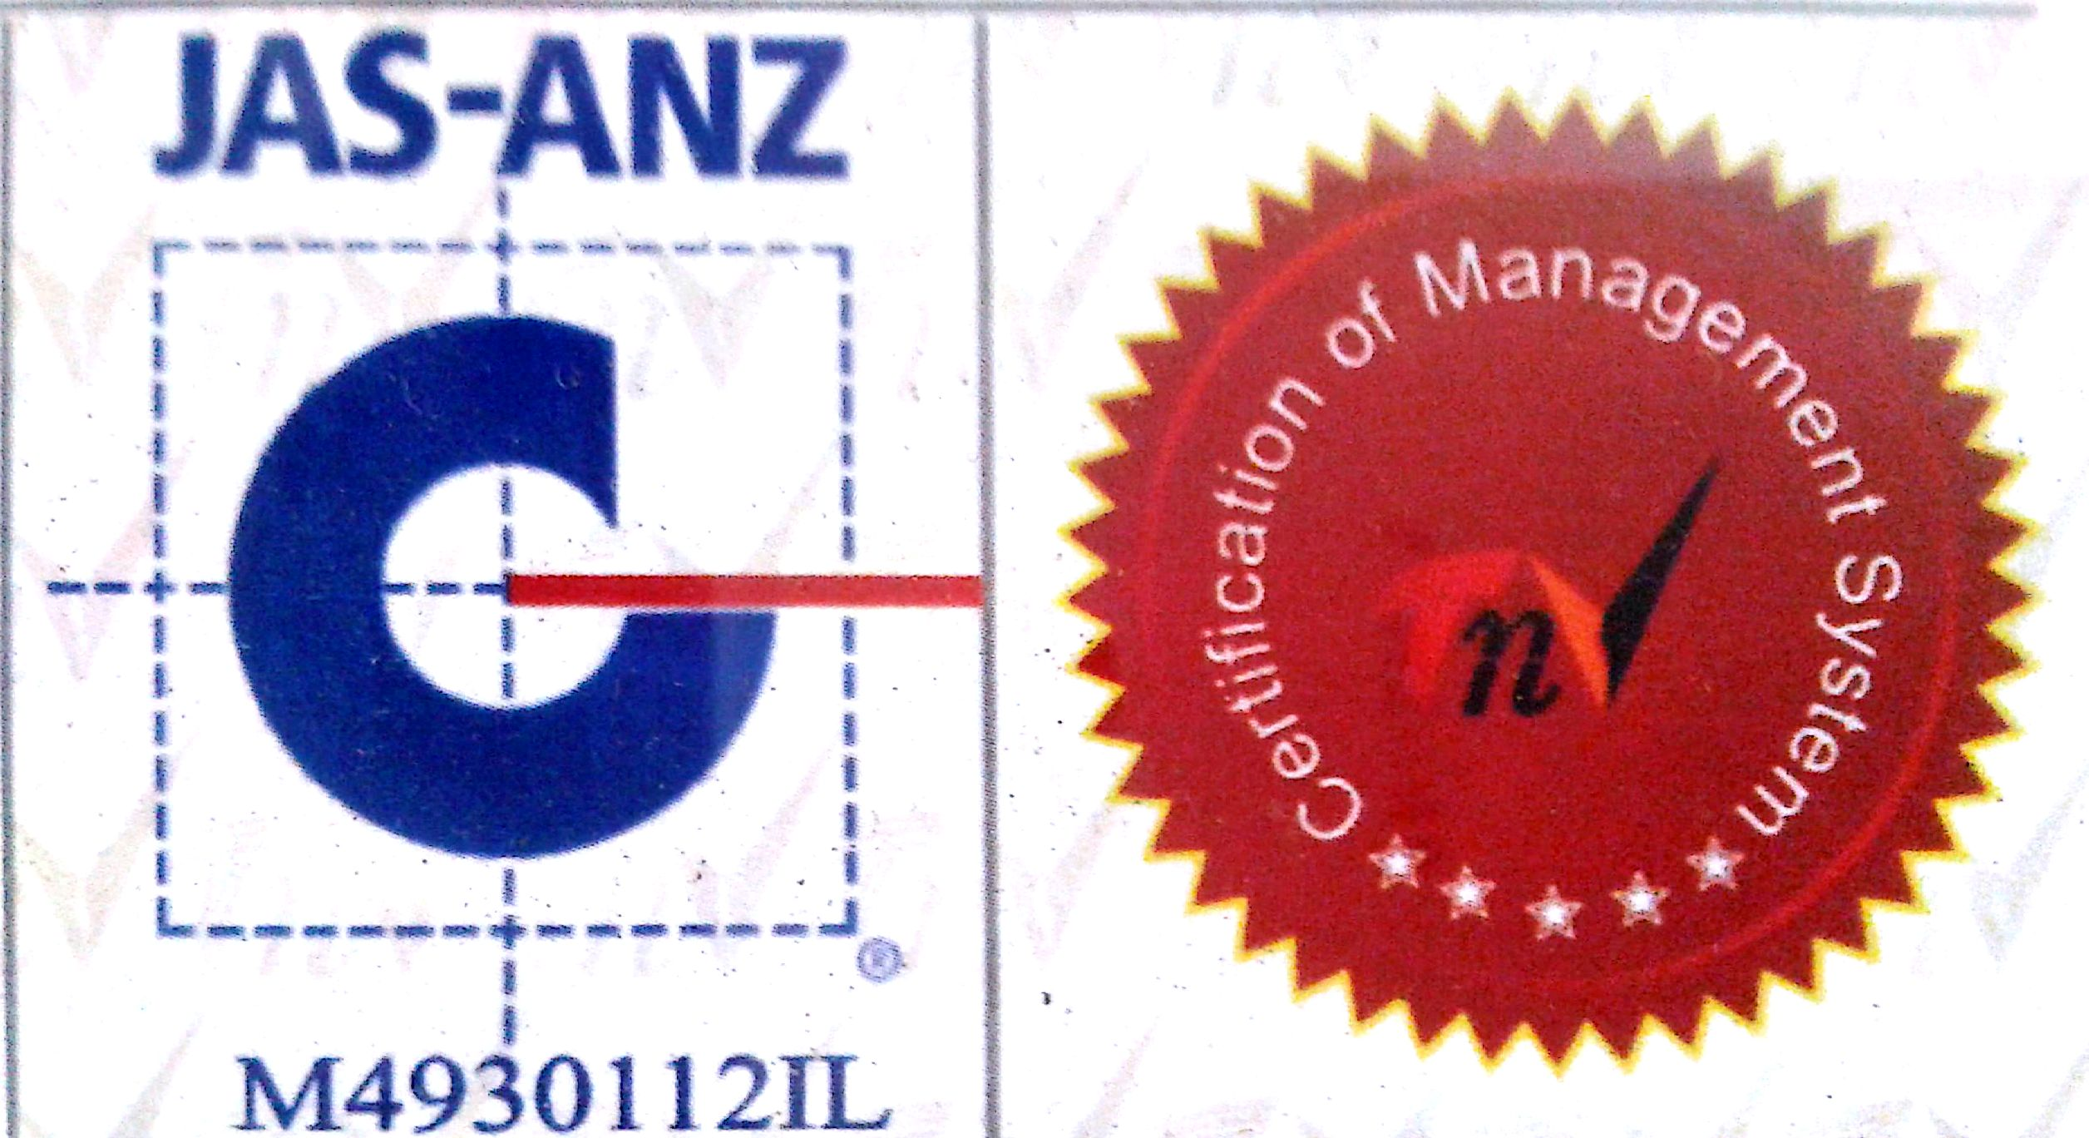

MTL/ FO/ 15
NEW DELHI MUNICIPAL COUNCIL

MATERIAL TESTING LABORATORY
QUALITY CONTROL CELL
VIDYUT BHAWAN, NEW DELHI
TEST REPORT OF SIEVE ANALYSIS

1. Name of work
2. Agency
3. Date of receipt of Sample in Lab.
4. Date of test
5. Weight of Sample for test
6. Sieve analysis for ____40mm_______Graded nominal Size aggregate.

Sieve Size  (mm) | Weight of Aggregate in gms. |  | % age Passing | Remarks  Required Passing % age
Sieve Size  (mm) | Retained | Passing | % age Passing | Remarks  Required Passing % age
80 |  |  |  | 100%
40 |  |  |  | 95% to 100%
20 |  |  |  | 30% to 70%
10 |  |  |  | 10% to 35%
4.75 |  |  |  | 00% to 5%
PAN |  | ------------ | ------------ | ------------

A.E.(LAB) E.E.(Q.C.& T.A)-I

