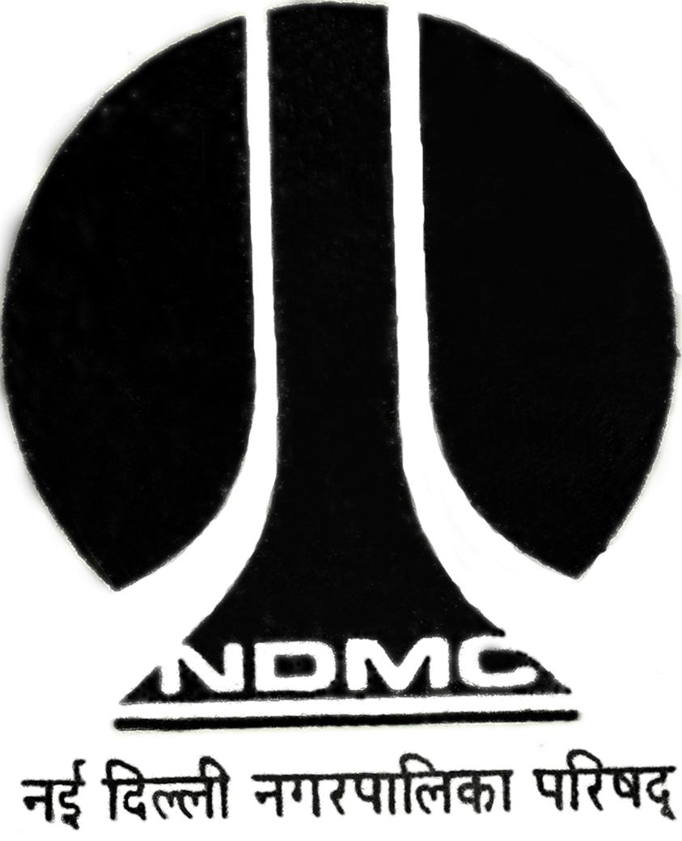
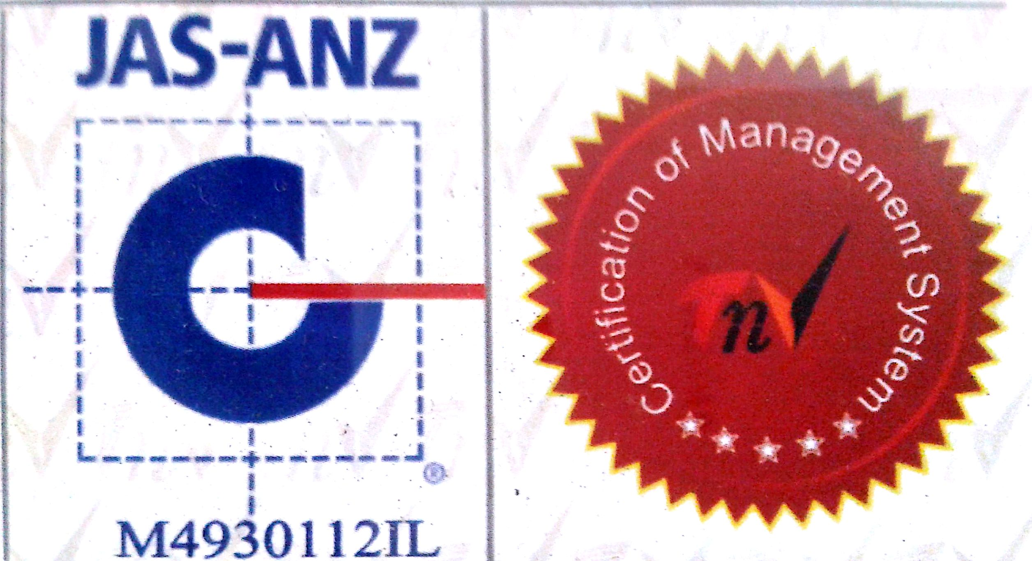

MTL/ FO/ 13
NEW DELHI MUNICIPAL COUNCIL

MATERIAL TESTING LABORATORY
QUALITY CONTROL CELL
VIDYUT BHAWAN, NEW DELHI
ABRASION TEST FOR AGGREGATES

- Name of Work :-
:-
- Details from where sample is collected :-
- Name of Department / Agency :-
- Name of Division :-
- Name of Executive Engineer :-
- Name of Assistant Engineer :-
- Name of Junior Engineer :-
- Name of Contractor :-
- Size and Weight of the Aggregate :-
- Date of Collection :-
- Remarks :-

J.E. (Work) Sig. of Contractor A.E. ( ) E.E. ( )

RESULTS OF THE TEST

Wt. of sample is taken for the test………………………………………………………………………..…………gm.

Wt. of the aggregate coarser than 1.70 mm……………………………………………………………….………gm.

Loss of weight due to wear..…………………………………………………………………………………………gm.

Percentage Wear…………………………………………………………………………………………………………..

Abrasion Value….…………………………………………………………………………………………………………

A.E. (Lab.) E.E.(Q.C.& T.A.)-I

