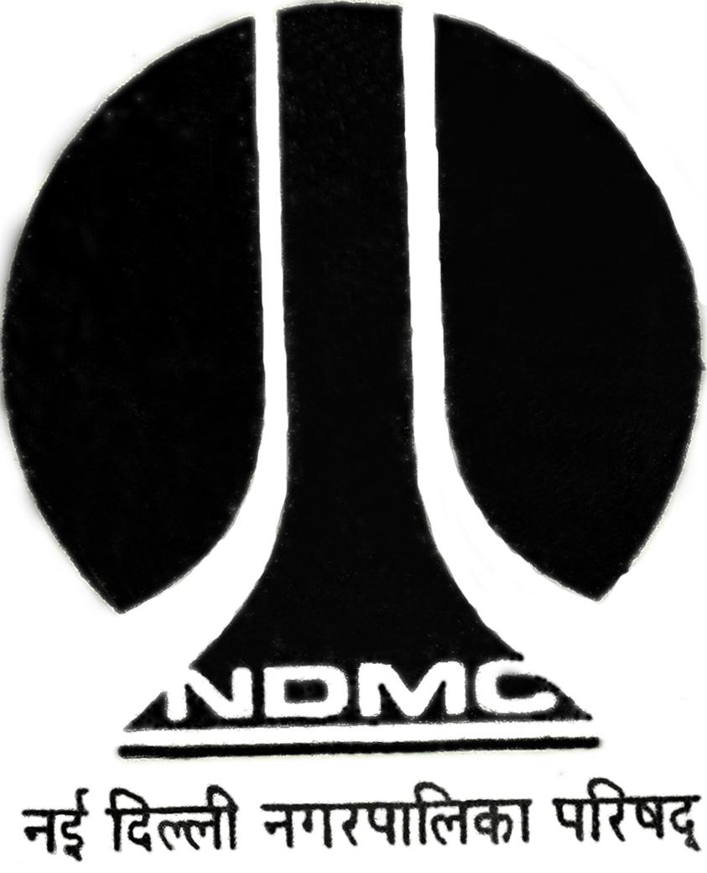
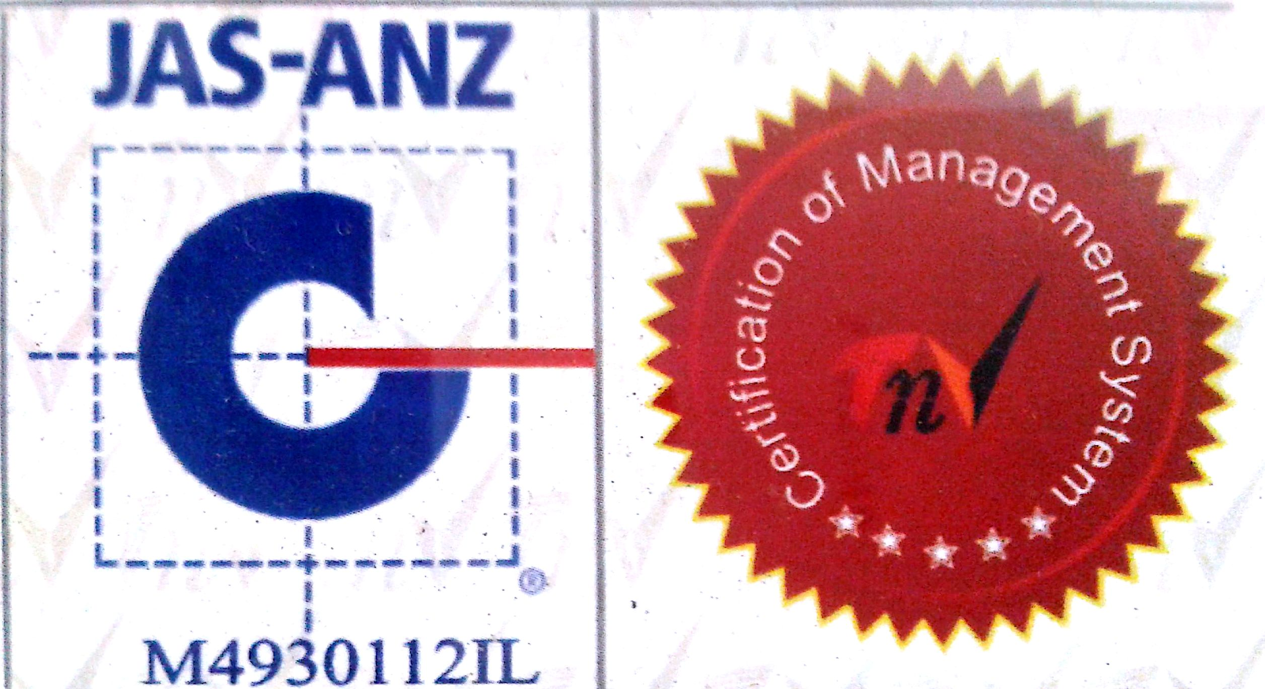
MTL/ FO/ 12
NEW DELHI MUNICIPAL COUNCIL

AGGREGATE IMPACT TEST

- Name of Work :-

- Details from where sample is collected :-
- Name of Agency :-
- Name of Division :-
- Name of Executive Engineer :-
- Name of Assistant Engineer :-
- Name of Junior Engineer :-
- Size and Weight of Aggregate :-
- Date of Collection :-
- No. of samples :-

Sig. of J.E.( ) Sig. of Contractor Sig. of A.E. ( ) Sig. of E.E. ( )

CALCULATION AND RESULTS:-
Wt. of the Sample taken | (1) ……………………………gm.  (2) ……………………………gm. | (1) ……………………………gm.  (2) ……………………………gm.
Wt. of fraction passing  2.36 mm I.S. Sieve | (1) ……………………………gm.  (2) ……………………………gm. | (1) ……………………………gm.  (2) ……………………………gm.
Aggregate Impact Value | (1) ………………………………%  (2) ………………………………% | (1) ………………………………%  (2) ………………………………%
Average Impact Value : |  | ………………………………%

A.E. (Lab) E.E.(Q.C.& T.A.)-I

