
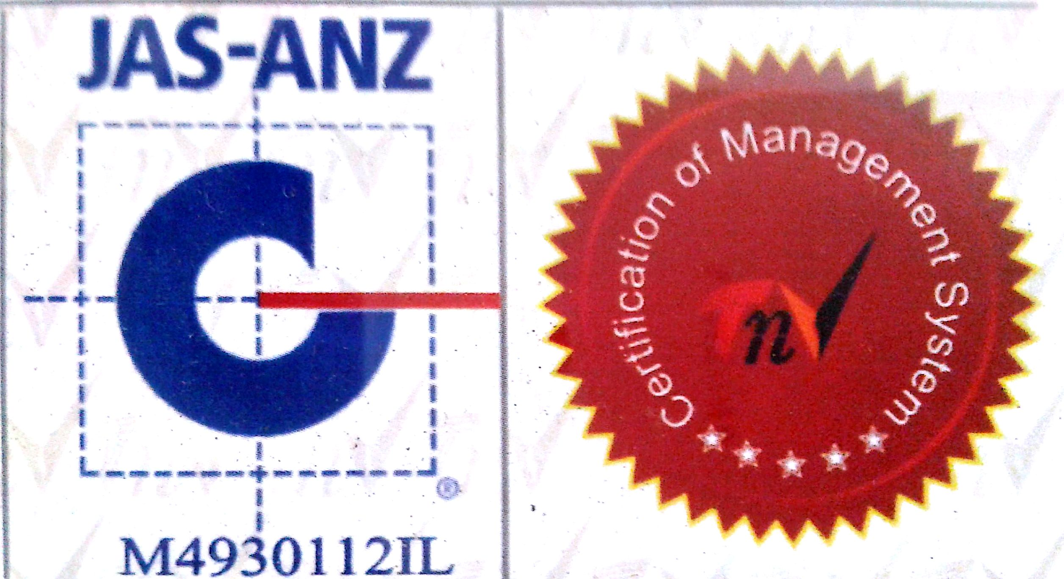

MTL/ FO/ 11
NEW DELHI MUNICIPAL COUNCIL

MATERIAL TESTING LABORATORY
QUALITY CONTROL CELL
VIDYUT BHAWAN, NEW DELHI
TEST REPORT OF FLAKINESS INDEX
1. Name of Work :-
2. Name of Division :-
3. Sample received in Lab on :-
4. Date of Test :-
5. Wt .of Sample taken for test (WI) gm :-
6. Normal size of aggregate in mm. :-
Size of Aggregate |  | Corresponding Thickness Gauge size mm. | Wt. of Agg. Passing through the Thickness Gauge (W₂ ) gm.
Passing through I.S. sieve mm. | Retained on I.S. sieve mm. | Corresponding Thickness Gauge size mm. | Wt. of Agg. Passing through the Thickness Gauge (W₂ ) gm.
63 | 50 | 33.9
50 | 40 | 27
40 | 31.5 | 19.5
31.5 | 25 | 16.95
25 | 20 | 13.50
20 | 16 | 10.80
16 | 12.5 | 8.55
12.5 | 10 | 6.75
10 | 6.3 | 4.89

Total of W₂ = gm.
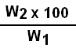
Flakiness Index = =

A.E. (Lab) E.E. (Q.C.& T.A.)-I

