COUNCIL’S MEETING NO. 07/2006-2007 DATED 20.09.2006 AT 2-30 P.M.

LIST OF BUSINESS AS PER THE SECTION 23 NDMC ACT & SECTION 14 OF THE PROCEDURE AND CONDUCT BUSINESS REGULATIONS, 1997.

Item No. | Business
1 | Confirmation of the Council’s Meeting held on 17.8.2006.
2 | Question asked by Member of the Council.
3 | Business from the Chairperson.
4 | Reports of Committees constituted under section 9 of the NDMC Act.

ITEM NO. 1 (C-26)

Confirmation and signing of the minutes of adjourned Council’s Meeting No. 06/2006-07 held on 17.08.2006, at 3.00 P.M., at Committee Room, Palika Kendra, NDMC. ( See Page 3).

COUNCIL’S DECISION

Confirmed

NEW DELHI MUNICIPAL COUNCIL

PALIKA KENDRA : NEW DELHI

MINUTES OF THE COUNCIL’S MEETING NO. 06/2006-2007

HELD ON 17.08.2006.

MEETING NO. | : | 06/2006-2007
DATED | : | 17.08.2006
TIME | : | 02-30 P.M.
PLACE | : | PALIKA KENDRA, NEW DELHI.

PRESENT :

1. Smt. Sindhushree Khullar - Chairperson
2. Sh. Ashok Ahuja - Member
3. Sh. V.V. Bhat - Member
4. Sh. M.M. Kutty - Member
5. Sh. Rakesh Kumar - Member
6. Dr. K.S. Sugathan - (on granted leave of absence)
7. Sh. Keshav Chandra - Secretary, N.D.M.C.

In the Council Meeting, as there was no quorum, the meeting was adjourned till 3-00 P.M. In the adjourned meeting, oath was administered to two newly nominated Members viz. Sh. M.M. Kutty, Joint Secretary, (Delhi & Land), Ministry of Urban Development, Govt. of India and Sh. Rakesh Kumar, Land & Development Officer, Ministry of Urban Development, Govt. of India. The minutes of the Council’s Meeting held on 19.07.2006 was also confirmed after incorporating the view of the Members received vide Letter dated 14.08.2006.

The contents of the Letter dated 17.08.2006 from Ms. Tazdar Babar, MLA & Vice Chairperson, Sh. Ashok Ahuja, MLA & Member, Ms. Sima Gulati & Sh. Mukesh Bhat, Members, were brought before the Council. The said letter included an annexure of the Items and Resolutions on which reports was to be placed before the Council.

It was decided that follow up action on the annexure be placed in the next meeting of the Council.

QUESTIONS ASKED BY THE MEMBERS OF THE COUNCIL

Council’s question asked by mr. mukesh bhatt, MEMBER, NDMC,
U/S 28 OF THE NDMC ACT

S.No. | Question
a) | How many consultants have been appointed by NDMC during the period from 2000 till date ?
b) | What are their areas of consultancy and / or project for which they have been appointed ?
c) | What are their period of appointment and what remuneration is being paid ?
d) | Kindly furnish the detail of each such Consultants viz. their complete profile.
e) | What are the guidelines of Govt. of India for appointment of Consultants ?
f) | Whether guidelines prescribed by Govt. of India for such appointments are strictly adhered to ?
g) | If not, the reasons thereof ?

Reply of these questions will be laid on the table, at the Council Meeting.

BUSINESS FROM THE CHAIRPERSON :-

A. Business related to Tender and other important issues :-

item no. | SUBJECT | Page | annexure
1. (C-27) | Action Taken Report on 90 Resolutions passed by the Council from January 2006 to June 2006. | 6 | 7-42
2. (A-21) | Addition/Alteration at Primary School, Pandara Road, New Delhi. | 43-46
3. (A-22) | Preservation/Restoration of Heritage Building in NDMC area. SH : Restoration of Gole Market and surrounding Building i/c implementation of signages, street furnitures, façade restoration with rehabilitation of structures & its services, interior restoration & upgradation. | 47-49
4. (A-23) | Preservation/Restoration of Heritage Building in NDMC area. SH : Façade Restoration of N.P. Boys Sr. Sec. School, Mandir Marg, N.Delhi. | 50-52
5. (A-24) | Approval of revised PE of Rs. 5,96,09,200/- for the construction of a State of Art Radio Imaging Diagnostic Centre with facilities of MRI, CT Scan and Mammography at Dharam Marg, New Delhi in place of 50 bedded Maternity Hospital and staff Qrs as proposed earlier. | 53-58 | 59-73
6. (A-25) | S/R of roads in NDMC area. Resurfacing of colony roads by lanes/service road by providing 2.5 cm thck dense graded asphaltic concerete in Moti Bagh, Sarojini Nagar, Nauroji Nagar, Netaji Nagar & Laxmi Bai Nagar area. | 74-77
7. (M-6) | Outsourcing for Leasing of Computer Hardware, Software & connected accessories and providing manpower for imparting of computer education in NDMC/Navyug Schools. | 78-80 | 81 - 83
8. (A-26) | Development of various markets in NDMC area.  SH : Façade Improvement for Janpath Road Berm Market (between Outer Circle and Tolstoy Marg) | 84-87
9. (A-27) | R/M of Bosster Pumps & Tubewells in NDMC Area. SH : Survey Report of dismantled electrical & Mechanical items. | 88-89
10. (C-28) | Contracts/Schemes involving an expenditure of Rs. 1 Lac but not exceeding Rs. 50 Lacs. | 90 | 91-104
11. (C-29) | Action Taken Report on the status of ongoing schemes / works approved by the Council. | 105 | 106-128
12. (C-30) | Report of the Committee constituted under Section 9 of the NDMC Act. | 129

ITEM NO. 1(C-27)

ACTION TAKEN REPORT ON 90 RESOLUTIONS PASSED BY THE COUNCIL FROM JANUARY 2006 TO JUNE 2006.

1. | Number of Regular Council Meeting held from January 2006 to June, 2006 | 05
2 | Number of Special Meeting | 02
3 | Number of Budget Meeting | 01
4 | Total number of Resolutions | 90

S.No. | Details of Meeting | Date | No. of Items | Total no. of Members present in the Meeting
1 | 10/2005-06 | 19th January 2006 | Oath taken by the new Council at LG House. | 11
2 | 11/2005-06 | 13th February 2006 | 19 | 08
3 | 12/2005-06 (Special Meeting) | 1st March 2006 | 01 | 07
4 | 13/2005-06 (Budget Meeting) | 30th March 2006 | 03 | 07
5 | 01/2006-07 | 19th April 2006 | 19 | 08
6 | 02/2006-07 (Special Meeting) | 26th April 2006 | 01 | 07
7 | 03/2006-07 | 19th May 2006 | 35 | 07
8 | 04/2006-07 | 21st June 2006 | 12 | 06

The ATR on Resolutions passed by the Council, shall be placed before the Council quarterly.
Accordingly, ATR will be placed in the Council in the month of August, for the quarter April to June, in the month of November for the quarter July to September, in the month of February for the quarter October to December and in the month of May for the quarter January to March.

The ATR for the period from January, 2006 to June 2006 is placed before the Council for information (See pages 7-42).

COUNCIL’S DECISION

Information noted.
However, the Council desired additional information on following agenda points:-
- 18 (at page 34) and 26: Latest status on the matter be placed before the Council. Department to place before the Council order and remarks by the Hon’ble Supreme Court in this matter
- 28: The date of award of work has been shown as 15.08.2006, which is a National holiday. Department to clarify.
- 44: Latest status on handing over of maintenance of Civil & Electrical services of PM Office to CPWD.
- 47: Details of specification of Tipper Trucks hired by NDMC.
ANNEXURE 36 PAGES

ANNEXURE END
ITEM NO. 2(A- 21)

1. Name of the subject/project

Addition/Alteration at Primary School, Pandara Road, New Delhi.

2. Name of the Department/Department concerned.

Civil Engineering Department Zone-II

3. Brief History of the subject/project

New Delhi Municipal Council is responsible for an area of 42.74 square kilometers. Various central govt offices, residence of Govt. official, institutions like hospitals, schools, Hon’ble Supreme Court & high Court resides in this area.

NDMC is responsible for providing basic civic amenities, various social, cultural educational & medical facilities to the people reside in this area.Hon’ble Delhi High Court gave necessary directive that N.P.Primary School, Shershah Mess Building is to be vacated on or before 30.04.2006 to hand over the vacant possession to L&D.O. The decision was taken by Council in its meeting held on 23.11.2005 & resolved vide resolution No. 12(m-7) that N.P.Primary School, Shershah Mess Building is to be vacated on or before 30.04.2006 to hand over the vacant possession to L&D.O. Site was inspected on 25.11.2005 and again On 30.11.2005 when CA, Director Education, SE (C-II), F.O. cum-NA, EE(C-V) & EE(Design) were also present. As desired by CA the site plan was prepared & submitted to CA Department for preparation of proposal.

The drawings of proposed work from Architect department were received and accordingly preliminary estimate amounting to Rs.65,53,000.00 on PAR and actual had been prepared.

4. Detailed Proposal of the subject/project:

Following modifications/addition are proposed to accommodate Sher Shah Mess School.

Ground Floor

- Addition of one no. class room size 6.00x5.00m
- Addition of toilet block.
- Additional stair case for fire escape staircase.
- Re alignment of store & toilets (internal modification).
- Change of classroom in toilet at Ground floor in front of fix scope stair case.
- Dismantling of store.
- Additional toilet for staff.
- Change in the alignment of wall of class room to match the verandah on Nursery side.
- Re alignment of entry/exist.

First Floor

- Addition of one no. class room size 6.00x5.00m
- Addition of toilet block.
- Additional stair case for fire escape staircase.
- Re alignment of store & toilets (internal modification).
- Creating class room by dividing bigger class room.
- Dismantling of store.
- Additional toilet for staff.
- Change in the alignment of wall of class room to match the verandah
towards Nursery side.
- Re alignment of entry/exist.

Second Floor
Creating 5 class room, toilet block & store as additional storey.
Structural Design :
RCC framed structure with provision of earth quake resistance and loadbearing structure in combination has been considered in framing estimate.

Specification :
Latest CPWD specification.
Flooring :
Rooms : Marble chip flooring/marble chip tile flooring.
Toilet, W.C. : Marble chip flooring, tiles upto 7’ height in bathrooms,
Tiles upto 5’ height in kitchen and W.C. Doors & Windows

Doors : Hard wood panel door(factory made)

Door Frame : M.S. Door Frame

Windows ; Aluminium Frame

Cub Board : M.S. Godrej Type.

Finishing

Inside : White wash/oil bound distemper.

Outer finish : Rough cast plaster with water proofing cement paint

Terrace finishing : Mud phaska with water proofing.

Over Head Tank : 500 ltrs. P.V.C. Tanks.

5. Financial Implications of the proposed project/subject.
On the basis of architectural drawings preliminary estimate amounting to Rs.65,53,000.00 based on plinth area rates 1992 with 123% cost index has been prepared.

Preliminary estimate checked by planning division forwarded to Chief Engineer for further submission to finance for their concurrence. Due to urgency of work in view of the direction of Delhi High Court a meeting was held in the chamber of Secretary, NDMC for assessing the progress.

During discussion and elaboration it was worked out to complete the work in time frame manner by splitting the work in three parts and approval from Chairperson was sought for

- To take up the work in anticipation of A/A & E/S by council on getting the approval by circulating the agendum item to members.
- To construct four class rooms at terrace along with toilets through call of short notice quotation.
- For construction of three class rooms adjoining the existing nursery school along with the toilet block through call of short notice quotation to be converted to into agreement.
- Fire escape staircase including addition alteration in the existing toilets through short notice quotations to be converted into agreement.

The Chairperson NDMC on 21.3.2006 vide Noting page 9 of the relevant file has accorded the approval.

- Implementation schedule with timeliness for each stage including internal processing.

The work additional class room and toilet work abutting nursery block will be completed within six months after issue of work order. The work of additional class room at second floor and fire escape stair case has already been taken up and will be completed by 15.07.2006.

- Comments of the Finance Department on the subject.

We concur in the PE amounting to Rs.65,53,000/-)sixty five lakh fifty three thousand only) as checked by Planning Department subject to the following:

- The structural stability of the building on which additional floor is to be added is to be ensured before according technical sanction to the scheme.

- Copy of the orders of High Court for eviction from school building situated at Shershah Marg may be added to the file for record.

- Sufficient funds are available expenditure chargeable to D.1.4 items.
- The matter be routed through E-in-C before placing the same before Council for approval of A/A & E/S.

This issues with the approval of F.A.

- Comments of the Deptt. on comment of the Finance Deptt.

The Finance Department concurred in Preliminary Estimate amounting to Rs.65,53,000/- with certain observations which are clarified as under:

- The structural drawings were issued by Design Division for proposed work.
- Copy of the High Court Order is added herewith for record please.
- Revised R.E. will be sought.
- As advised file please be routed through E-in-C Office.

9. Legal Implication of the Subject/Project:
Nil

10. Details of previous Council Resolution/Existing law of Parliament & Assembly on the subject.
12(m-7)

11. Comments of the Law Department on the Subject/Project.

No legal point is involved. This has our concurrence.
This issues with the prior approval of L.A.

12. Comments of the Deptt. on the comments of the Law Deptt.
Nil

13. Recommendation:

The case may be noted to council for according administrative approval and expenditure sanction of the preliminary estimate amounting to Rs.65,53,000.00 (Rs. Sixty five lacs fifty three thousand only) for Addition/Alternation at Primary School, Pandara Road, New Delhi.

14. Draft Resolution.
Resolved by the Council that Administrative Approval and expenditure sanction is accorded to the preliminary estimate amounting to Rs.65,53,000.00 (Rs. Sixty five lacs fifty three thousand only) for Addition/Alternation at Primary School, Pandara Road, New Delhi.

COUNCIL’S DECISION

Resolved by the Council that Administrative approval and expenditure sanction to the preliminary estimate amounting to Rs.65,53,000.00(Rs. Sixty five lacs fifty three thousand only) is accorded for addition/alteration at Primary School, Pandara Road, New Delhi.

Further resolved by the Council that the matter be taken up with L&DO vigorously by the department for allotment of alternative plot to NDMC for the construction of school in lieu of NP Pry. School Building at Shershah Mess.

ITEM NO. 3(A-22)

1. Name of the subject/ project :

Sub: Preservation/Restoration of Heritage Building in NDMC area.

SH : Restoration of Gole Market and surrounding Building i/c implementation of

signages, street furnitures, façade restoration with rehabilitation of

structures & its services, interior restoration & upgradation.

2. Name of the deptt./deptt. concerned :

Civil Engg. Deptt., NDMC

3.. Brief History :

Gole Market and its surrounding building/structures has survived the hazards of time and provides the tangible link between the past and present giving a continuous cultural identity and is an architecturally significant, carry strong cultural overtones and being a part of cities heritage need care/conservation. This being an essential component in a civilized society through which architectural, aesthetic, social economic, political and cultural values of the past are observed, besides it shows an architectural, aesthetic, historic of cultural values with local landmark contributing to the image and identity of the city and thus, required to be restored to its old glory by preserving & restoration of building.

The design of the existing street furniture, signs, garbage bins, tree planters as they exist in the area are incongruous to the ambience of this heritage historic building and installation of plaques and information posts with other signages etc could go a long way in not only establishing the identity of the area but also instilling pride to the occupants and users of the historic building of the area by adopting the use of right type of street furnitures i/c interior restoration & upgradation.

4. Detailed proposal on the subject/project:

An estimate amounting to Rs. 6,31,60,535/- approx. has been framed to obtain the A/A & E/S from the Council. The brief summary of the cost involved in the project is given as under.

Part A:

1. Façade Resttoration & Roof repairs Rs. 1,02,00,000/.-

2. Street Furniture Rs. 1,06,41,500/-

Part B :

1. Courtyard Restoration Rs. 61,26,250/-

2. Services Rs. 67,53,710/-

3. Pedestrian Subway Rs. 1,44,39,075/-

Part C :

Interior Restoration Rs. 1,50,00,000/-

Grand Total (A+B+C) Rs. 6,31,60,535/-

5. Financial implications of the proposed project/subject:

The total financial implications of the project/subject would be Rs. 6,31,60,535/- approx. This amount is on the basis of details submitted by an Architect Consultant appointed for Architectural & Conservation, Design Consultancy for Implementation of Façade Restoration of Gole Market Restoration & its Precincts.

There is a budget provision of Rs. 10,00,000/- exists under the Head of A/C H.1.8 vide item no. 281 during the year 2006-07.

- Implementation schedule with timeliness for each stage including internal processing:

TENTATIVE TIME SCHEDULE

Sl.No | Stage/Activity | Time | Target date | Remarks
1. | Appointment of consultant and signing of agreement. |  |  | Completed.
2. | Concept design and Report Rough cost etc. |  | 20.03.06 | Completed
3. | Preliminary design, drawings incorporations of modification suggested by employer, preliminary estimates. |  | 05.05.06 | Completed
4. | Submission to DUAC and Heritage Committee. |  | 31.07.06 | Drawings & Models has been submitted.
5. | Approval by statutory body |  | 30.09.06
6. | Working drawings, Tender documents, Bill of Quantities, short listing of contractor, Tendering process |  | 31.12.06
7. | Completion of work | 54 weeks | Dec. 07
8. | Likely commissioning of Project in all respects |  | 31.03.08 | -

- Comments of the Finance Deptt. on the subject:

In view of clarification given by the deptt. as well as recommendation of CE (C-II), we concur in the PE amounting to Rs. 6,31,60,535/- (Rs. Six Crore thrity one lac sixty thousand five hundred thirty five only) for the work of Façade Restoration of Gole Market and its surrounding buildings subject to:

- The estimate has been submitted by the consultant and same has been checked on their rates as such due care be taken in while submitting the detailed estimate in the Planning Division alongwith drawing.
- Correctness of data.
- Availability of funds.
- Approval of Competent Authority
- Execution of work by adhering codal provisions.
- Comments of the Department on comments of Finance Deptt.

It is clarified as under:

1 & 2. Due care shall be taken while submitting the detailed estimate in the Planning

Division alongwith drawing about the correctness of data & rates.
- Sufficient funds are available.
- The case is placed before the Council for its approval.
- The work shall be got executed by adhering codal provisions.

- Legal Implication of the project:

NIL

10. Details of previous Council Resolutions, existing law of

Parliament and Assembly on the Subject:

NIL

- Comments of the Law Department on the subject/Project

As no legal implication involved, hence the matter was not submitted to the Law

Deptt.

- Comments of the Department on the comments of Law Deptt.

No Comments

- Recommendation

The case is placed before the Council for approval of the proposal & to accord Administrative Approval & Expenditure sanction to the Preliminary Estimate amounting to Rs. 6,31,60,535/- (Rs. Six Crores thirty one lacs sixty thousand five hundred thirty five only).

COUNCIL’S DECISION

Resolved by the Council that administrative approval and expenditure sanction to the preliminary estimate amounting to Rs.6,31,60,535/- is accorded.

Further resolved by the Council the licensees/shopkeepers of Gole Market will be relocated only for the period for which a particular shop is being renovated and would be put back in position of the shop as soon as the renovation of the shop is complete.

It has also been resolved that the Market Association and occupants of the shops would also be taken into the confidence and the proposed restoration be done taking into the suggestions coming from that quarter.

Further resolved by the Council that a presentation be made to the Council in the next meeting of the Council.

ITEM NO. 4(A-23)

1. Name of the subject/Project :

Sub: Preservation/Restoration of Heritage Building in NDMC area.

SH : Façade Restoration of N.P. Boys Sr. Sec. School, Mandir Marg, N.Delhi.

2.. Name of the deptt./deptt. concerned :

Civil Engg. Deptt., NDMC

3. Brief History:

N.P. Boys Sr. Sec. School and its surrounding building/structures has survived the hazards of time and provides the tangible link between the past and present giving a continuous cultural identity and is an architecturally significant, carry strong cultural overtones and being a part of cities heritage need care/conservation. This being an essential component in a civilized society through which architectural, aesthetic, social economic, political and cultural values of the past are observed, besides it shows an architectural, aesthetic, historic of cultural values with local landmark contributing to the image and identity of the city and thus required to be restored to its old glory by preserving & restoration of the same.

4. Detailed proposal on the subject/project:

An estimate amounting to Rs. 2,02,00,000/- approx. has been framed to obtain the A/A & E/S from the Council for restoration of the front façade of the building, restoration of water proofing work, structural cracks, all sensitive historical features, repair of old masonry structure, restoration of garden, illumination of building etc. so as to have the original magnificent elevation.

5. Financial implications of the proposed project/subject:

The total financial implications of the project/subject would be Rs. 2,02,00,000/- approx. This amount is on the basis of details submitted by an Architect Consultant appointed for Architectural & Conservation, Design Consultancy for Implementation of Façade Restoration of N.P. Boys Sr. Sec. School, Mandir Marg, New Delhi.

There is a budget provision of Rs. 10,00,000/- exists under the Head of A/C H.1.8 vide item no. 281 during the year 2006-07.

6. Implementation schedule with timeliness for each stage including internal processing:

TENTATIVE TIME SCHEDULE

Sl.No | Stage/Activity | Time | Target date | Remarks
1. | Appointment of consultant and signing of agreement. |  |  | Completed.
2. | Concept design and Report Rough cost etc. |  | 11.03.06 | Completed
3. | Preliminary design, drawings incorporations of modification suggested by employer, preliminary estimates. |  | 24.04.06 | Completed
4. | Submission to DUAC and Heritage Committee. |  | 31.07.06 | Permission from the Heritage Committee granted in June, 06.  Drawings has been submitted to DUAC.
5. | Approval by statutory body |  | 30.09.06
6. | Working drawings, Tender documents, Bill of Quantities, short listing of contractor, Tendering process |  | 31.12.06
7. | Completion of work | 54 weeks | Dec. 07
8. | Likely commissioning of Project in all respects |  | 31.03.08 | -

- Comments of the Finance Deptt. on the subject:

In view of the clarification given by the deptt. as well as recommendation of CE (C-II), we concur in the PE amounting to Rs. 2,02,00,000/- (Rs. Two Crore two lac) for the work of Façade Restoration of N.P. Boys Sr. Sec. School, Mandir Marg, New Delhi, subject to :-

- The estimate has been submitted by the consultant and same has been checked on their rates as such due care be taken in while submitting the detailed estimate in the Planning Division alongwith drawing.
- Correctness of data.
- Availability of funds.
- Approval of Competent Authority
- Execution of work by adhering codal provisions.

- Comments of the Department on comments of Finance Deptt.

It is clarified as under:

1 & 2. Due care shall be taken while submitting the detailed

estimate in the Planning Division alongwith drawing etc. & its

correctness of data & rates.
- Sufficient funds are available.
- The case is placed before the Council for its approval.
- The work shall be got executed by adhering codal provisions.

- Legal Implication of the project:

NIL

10. Details of previous Council Resolutions, existing law of

Parliament and Assembly on the Subject:

NIL
- Comments of the Law Department on the subject/Project

As no legal implication involved, hence the matter was not submitted to the Law Deptt.

- Comments of the Department on the comments of Law Deptt.

No Comments

- Recommendation

The case is placed before the Council for approval of the proposal & to accord Administrative Approval & Expenditure sanction to the Preliminary Estimate amounting to Rs. 2,02,00,000/- (Rs. Two crores Two lacs only).

COUNCIL’S DECISION
Resolved by the Council that administrative approval & expenditure sanction to the Preliminary Estimate amounting to Rs.2,02,00,000/- is accorded.

Further resolved by the Council that during the restoration of N.P. Boys Sr. Sec. School not only the façade but the strengthening of the existing buildings and problems pertaining to seepage and other constructional weaknesses would also be dealt.

Further resolved by the Council that a presentation be made to the Council, highlighting not only façade strengthening of the existing building as well as retrofitting the building for its toilets and plugging seepages, in the next Council Meeting.

ITEM NO. 5(A-24)

1. Name of the subject / project.

Approval of revised PE of Rs. 5,96,09,200/- for the construction of a State of Art Radio Imaging Diagnostic Centre with facilities of MRI, CT Scan and Mammography at Dharam Marg, New Delhi in place of 50 bedded Maternity Hospital and staff Qrs as proposed earlier.

2. Name of the Department; Health (Medical Sector.)

Departments concerned – Civil Engineering, Electricity and Fire

3. Brief history of the subject/project.

It was decided on 27.09.1999 to construct a 50 bedded maternity hospital with staff quarters after demolition of the CWC building and the other structures in the CWC Complex at Dharam Marg, New Delhi.

The Council vides its resolution No. 3(v) dated 17.05.2001 accorded an administrative approval and expenditure sanction of Rs. 6,12,73,000/- towards preliminary estimate for the construction of a maternity hospital building comprising of one basement and 4 storeyed frame structure above the ground level with a provision of 4 lifts with a total covered area of 5445 sq mts. (Appendx.-I) (See pages 59 – 60). The estimate also contained the cost of construction of one type-V, two type-IV, eight type-III, eight type-II and 8 type-I flats with a total covered area of 1374 sq mts for the essential duty staff of the hospital. The Council also approved the Survey Report fixing reserve price at Rs. 5,23,792/- of the then existing CWC building and staff quarters vide its resolution No. 3(xvii) dated 27.03.2002. (Appendx.-II) (See page 61).

The work was awarded to M/s Vir Bhan Mittal on 18.07.2003. The expected date of completion of the work was 17.01.2005. The demolition work of the old structure was already completed and the excavation work for the construction of basement was in progress at the time of convening of the meeting of project review committee on 12.2.04

The Project Review Committee was informed in the meeting that the Delhi Urban Art Commission has not approved the drawings of the project on the ground that the ground coverage and the FAR proposed in the drawings were far in excess of the permissible limits of 33.33% ground coverage & 100% FAR.(Appendx. IV) (See pages (72 – 73). Thus, it was decided to omit the earlier proposed residential complex and the entire 3rd floor of the hospital building. Accordingly, the user department showed its inability to go on with the proposed project of construction of 50 bedded maternity hospital because of the following reasons:

- The residential quarters for the essential duty staff are a must for a maternity hospital to ensure their availability round the clock for providing uninterrupted services.
- The 3rd floor of the proposed hospital building had Operation Theatres and Recovery Room.. No maternity hospital can run without the provision of an Operation Theatre and Recovery Room. No space was available on other floors to accommodate these facilities as proposed at the 3rd floor of the earlier proposed building.
- By this time, Bio Medical Waste (Management & Handling Rules) 1998 notified on 20th July, 1998 also came into force. Accordingly, all hospitals, Nursing Homes, Clinics, Dispensaries, Veterinary Institutions and Animals Houses, Pathology Labs and Blood Banks etc etc. are required to take all steps necessary for the treatment and disposal of bio-medical waste in accordance with Schedule-I in compliance with the standards prescribed in Schedule-5 (Appendx.III) (See pages 62 – 71).

- Rule 5(2) binds every occupier generating bio medical waste to set up various bio medical waste treatment facilities like incinerator, Auto Clave Shredder and water Treatment facilities for the disposal of the waste within the time schedule prescribed in Schedule-6. The time frame prescribed under the rules was up to 31st December,2001 for a hospital with 50 beds or above, but less than 200 beds in a town with a population of below 30.0 lacs Thus, installation of an incinerator and other devices for proper treatment and disposal of biomedical waste became mandatory in the proposed hospital. However, there was neither a provision nor a scope for the installation of these devices in the proposed building. It was also apprehended that it might not be possible to install a 100 ft high chimney required for the elimination of a stalk in a posh area like Chanakyapuri because of the anticipated resistance from the neighbours/residents.

In view of the above considerations, it was suggested by the Project Committee to set up a State of Art Radio Imaging Diagnostic Centre comprising of MRI, CT Scan and Mammography facilities alongwith OPD treatment facilities in the discipline of Ayurved, Homoeopathy and Allopathy in place of 50 bedded maternity hospital without any changes in the building structure and foundation on 30.04.2004.

4. Detailed proposal of the subject.

MRI and CT Scan are essential for the precise diagnosis of a disease and planning its management especially in the cases of diagnosis of Neurological, Abdominal and road side accidents (Head injuries etc.). Although NDMC provides all these services, yet there are no facilities for these essential investigations in NDMC. The earlier proposal of the department for a CT Scan was abondoned in 2001 for want of sufficient space at CPH for its installation although the funds were allocated out of the plan scheme.

A need for a Mammography machine was also felt after the designation of Charak Palika Hospital, Moti Bagh as a first referral centre under the Cancer Detection Programme by Govt. of NCT of Delhi. In view of these facts, a State of Art Radio Imaging Diagnostic Centre with facilities of MRI, CT Scan and Mammography was proposed.

The competent authority reviewed the earlier decision of construction of 50 bedded maternity hospital & staff quarters on 30,04,2004 and decided to construct a State of Art Radio Imaging Diagnostic Centre with facilities of MRI, CT Scan and Mammography alongwith OPD services in the Ayurvedic, Homoeopathic and Allopathic systems of medicines. Accordingly, the Chief Architect issued modified drawings based on this decision in July, 2004. The proposed Diagnostic Centre will come up on a plot measuring 3,143.824 sq mts. The permissible ground coverage of a plot of this size is 33.3% i.e. 1.060.17 sq mts with a permissible FAR of 100%. In view of these restrictions, the Architect Department has proposed a ground coverage of 1001 sq mts with FAR of 2946 sq mts exclusive of basement in the modified drawings. The basement will have an additional plinth area of 1036 sq mts. The proposed building will comprise of a basement, ground floor and 2 storeys above this. Each floor will the following facilities:

- BASEMENT.

i) ESS and DG Set Room (ESS is not now being installed in the basement & the power shall be supplied by the Elect. Deptt. from the adjoining ESS)

ii) Space for storage.

iii) Scooter parking.

iv) Telephone Exchange – Electric Room and Pump House.

- GROUND FLOOR;

i) Reception
ii) MRI Unit.
iii) CT Scan Unit
iv) Mammography Unit.

C. FIRST FLOOR.

i) Doctors Chambers..
ii) Ayurvedic Dispensary
iii) Allopathic Dispensary

- SECOND FLOOR.

i) Doctors Chambers
ii) Homoeopathic Dispensary

There is a provision of two lifts in this building.

The work has already been awarded to M/s. Vir Bhan Mittal . The value of the work shall now get reduced to Rs. 3.30 crores as against the earlier contract value of Rs. 4.37 crores.

5. Financial implication of the proposed subject/project.

The expenditure shall be charged to the budget provision of Rs. 1 crore existing in the budget book ( item No. 70 P/75 ) for the year 2006-07 for the work of C/o 50 bedded Maternity Centre at Kitchner Road under statement V.( now State of Art Radio Imaging Diagnostic Centre)

6. Implementation Schedule with time limit for each stage including internal processing.

i) The Civil works have already been completed to the tune of 68% and the work is likely to be completed by 31st October, 2006.
ii) The Elect Deptt is yet to finalize the contract for the installation of lifts
iii) The Sprinkler System in the basement has been installed. The other fire fighting works shall run concurrently with the different stages of the completion of the construction of the building.
iv) The procurement of the machinery required for the project will be undertaken by the Concessionaire selected by inviting open tenders as per RFP in the process of being approved by NDMC as the said project has been proposed on a PPP model. This process of selection of Concessionaire and installation of machinery is likely to be completed in the year 2006-07.

7 Comments of the Finance Department on the subject.

The instant proposal, if seen in retrospect, reveals that the Council vide its resolution No. 3(v) dated 17.05.2001 accorded administrative approval and expenditure sanction to the scheme of providing 50 bedded maternity hospital and staff quarters at Kitchner Road at the estimated of Rs. 5,12,73,000/-. The work was awarded at tendered cost of Rs. 4,41,65,708/-. Subsequently, the scope of work was changed to C/o Diagnostic Centre some time in 2004 which resulted in reduction of scope of work (construction of staff quarters deleted and earlier the hospital building was a 4 storeyed structure besides basement). Reduction in scope of work resulted in reduction of cost by Rs. 1.11 crore as reported at ‘X’ on page 44/N. Revised estimate has now been checked by Planning at Rs. 5,96,09,200/-.

Arising out of above factual position, it may be pointed out that revision of estimate is only if the expenditure is likely to go beyond 10% of the expenditure sanction earlier accorded for the project. In the case in hand, such is not the case. The amount of revised estimate is less than the approved estimate. Hence, the necessity of seeking revised approval to the scope of work, it appears too late. Work has already been taken up as per changed scope of work. Now, it can be termed as Ex- post facto approval to the action initiated in 2004. For any material change in the scope of work earlier approved, Council should have been approached before hand i.e. in the year 2004 itself. By now most of work might have been completed. In such a scenario, Finance Department also do not have much to comment except to suggest that the whole issue giving complete detail including revised project report based on changed scope of work without seeking prior approval of the Council may be noted to the Council for approval decision.

Further, it has also been observed that at ‘X’ on page- 44/N, it has been brought on record that with the changed scope of work, the cost of the work would be reduced to Rs. 3.30 crores. Now the estimate has been prepared at Rs. 5,96,09,200/- with net excess of Rs. 2,66,09,200/-. No due justification in support of this excess cost alongwith the reasons for not taking this additional cost in the earlier cost has been brought on record. Such major deviations after according technical sanction to any scheme and strong indicators of inherent weakness in the scheme. This may be explained in detail to the Council.

8. Comments of the department on comments of Finance Department.

The change in the scope of the work had become necessary on the account of the reasons stated under column 3 (Brief history on the subject/project). As already explained, it was not possible to go on with the project of construction of 50 bedded maternity hospital and staff quarters. Therefore, the scope of work was changed to a construction of Radio Imaging Diagnostic Centre with facilities of MRI, CT Scan and Mammography and OPD services on 30.04.2004. . The reduction in scope of work resulted in reduction in cost by about Rs. 1.11 crore only for the civil works. In the said figures, the cost of electrical/fire fighting/horticulture works are not included.

The original PE was approved by the Council for Rs. 6,12 crores. The revised PE has been checked by Planning is Rs. 5,96,09,200/-. The amount of the revised PE is within the amount of original PE but revised approval of the Council is required as the cost of D.G.Set, Air Conditioning system, PA system etc. were not included in original PE.

With the changed scope of work, the cost of the civil works would get reduced to Rs. 3.30 crores against the contract value of Rs. 4.36 crores. The amount of revised PE Rs. 5,96,09,200/- with a net excess of Rs. 2,66,09,200/-. The justification in support of excess cost is given as under:

- The figure of Rs. 3.30 crores pertains to civil works only.
- The figure of Rs. 3.30 crores does not include the cost of Internal Electrical Installations, D.G.Set, installation of lifts, Air Conditioning system.
- In the original PE for the fire fighting work for an amount of Rs. 1,85,185/-, but as per the details of FO-cum-NA the expenditure on fire fighting works shall be to the tune of 35.0 lacs.
- A provision of horticulture works were made in the original PE for an amount of Rs. 57,378/-, but they have given an estimate for Rs. 1,80,100/-.

9. Legal implication of the subject/project.

The work was awarded to M/s. Vir Bhan Mittal for an agreement amount of Rs. 4.36 crores for C/o 50 bedded maternity hospital and staff quarters at Kitchner Road, New Delhi.

The scope of the work was reduced to Construction of Radio Imaging Diagnostic Centre with OPD treatment facilities in the Allopathic, Ayurvedic and Homoeopathic systems of medicine at Dharam Marg, New Delhi. The omission of the construction of staff quarters and the entire 3rd floor of hospital block has resulted in a significant reduction in the scope of construction work earlier awarded to M/s Vir Bhan Mittal in July, 2003. The total cost of the civil works on the basis of revised drawings shall be Rs. 3.30 crores as against the contract value of Rs. 4.36 crores calculated on the basis of covered area proposed in the original drawings. This pertinent variation in the terms & conditions of the contract agreement on account of reduction in value of work order might attract legal implications at a later date.

10. Details of previous Council Resolution, existing law of Parliament and Assembly on the subject.

The PE for the work was approved by the Council

- Rs. 6,12,73,000/- vide its resolution No. 3(v) dated 17.05.201
- The survey record for the old structure was approved by the Council Rs. 5,23,792/- vide resolution No. 3(xvii) dated 27.03.2001
- The proposed building must conform to the Building Bye laws applicable for the said area.
- The proposed project should be able to fulfill all the provisions of the Bio Medical Waste (Management & Handling Rules) 1998 as applicable for all hospitals and Nursing Homes etc.

11. Comments of Law Department on the subject/project.

There is no tender document available in file. Moreover, it is not clear whether acceptance from contractor obtained on revised proposal or not as awarded work was reduced later on after approval from Council, if there is no acceptance letter from contractor on revised terms and conditions and revised proposal then there can be litigation in future.

12. Comments of the Department on the comments of Law Department.

A copy of the agreement, tender documents is placed on the table. No acceptance from the contractor was obtained on revised proposal as the revised proposal has not yet been approved by the Council. The Contractor will be served with a notice under clause 13 of the agreement pertaining to foreclosure contract due to abandonment or reduction in scope of work after approval of this proposal by the Council.

13. Recommendations;

1. Council may kindly post-facto revise its decision dated 17.05,2001 for construction of 50 bedded maternity hospital and approve in its place construction of a State of Art Radio Imaging Diagnostic Centre with facilities of MRI, CT Scan and Mammography with Allopathic, Ayurvedic and Homoeopathic dispensaries.

2. The revised Preliminary Estimate of Rs. 5,96,09,200/- against earlier approval of Rs. 6,12,73,000/- may be approved for construction of revised scheme of setting up a State of Art Radio Imaging Diagnostic Centre comprising of facilities of MRI, CT Scan and Mammography and OPD services in Ayurvedic, Homoeopathic and Allopathic systems of medicine at Dharam Marg, New Delhi.

14. Draft Resolution.

  - Resolved by the Council that revised preliminary estimate of Rs. 5,96,09,200/- for the construction of a Diagnostic Centre against the earlier approval of Rs. 6,12,73,000/- for the construction of 50 bedded maternity hospital alongwith staff quarters is approved.

COUNCIL DECISION

The Council pointed out following observations:-

- An inquiry to be conducted to find out the reasons as to how construction was commenced and the contract was awarded without seeking approval of the Council and in anticipation of the approval from DUAC.

- The Council would like to fix a date for inspection of the facilities and the structures that have been erected at the site. Chief Architect may assist the Council with alternative use of the structure as per land use.

- 50 bedded Maternity Hospital and staff quarters proposed by the resolution dated 17.5.2001 be revised accordingly.

- Due justification in support of the excess cost above Rs.3.3 Crores alongwith the reasons for not taking this additional cost in the earlier cost is to be brought on record.

- Tender document is not available in the file. In the proposal, acceptance from the Contractor obtained on revised proposal on revised terms & conditions is not available which may invite litigation in future. It is also not clear that awarded work was reduced later on after the approval of the Council. Department is to furnish clarifications on this point.

In view of above, the matter has been deferred.

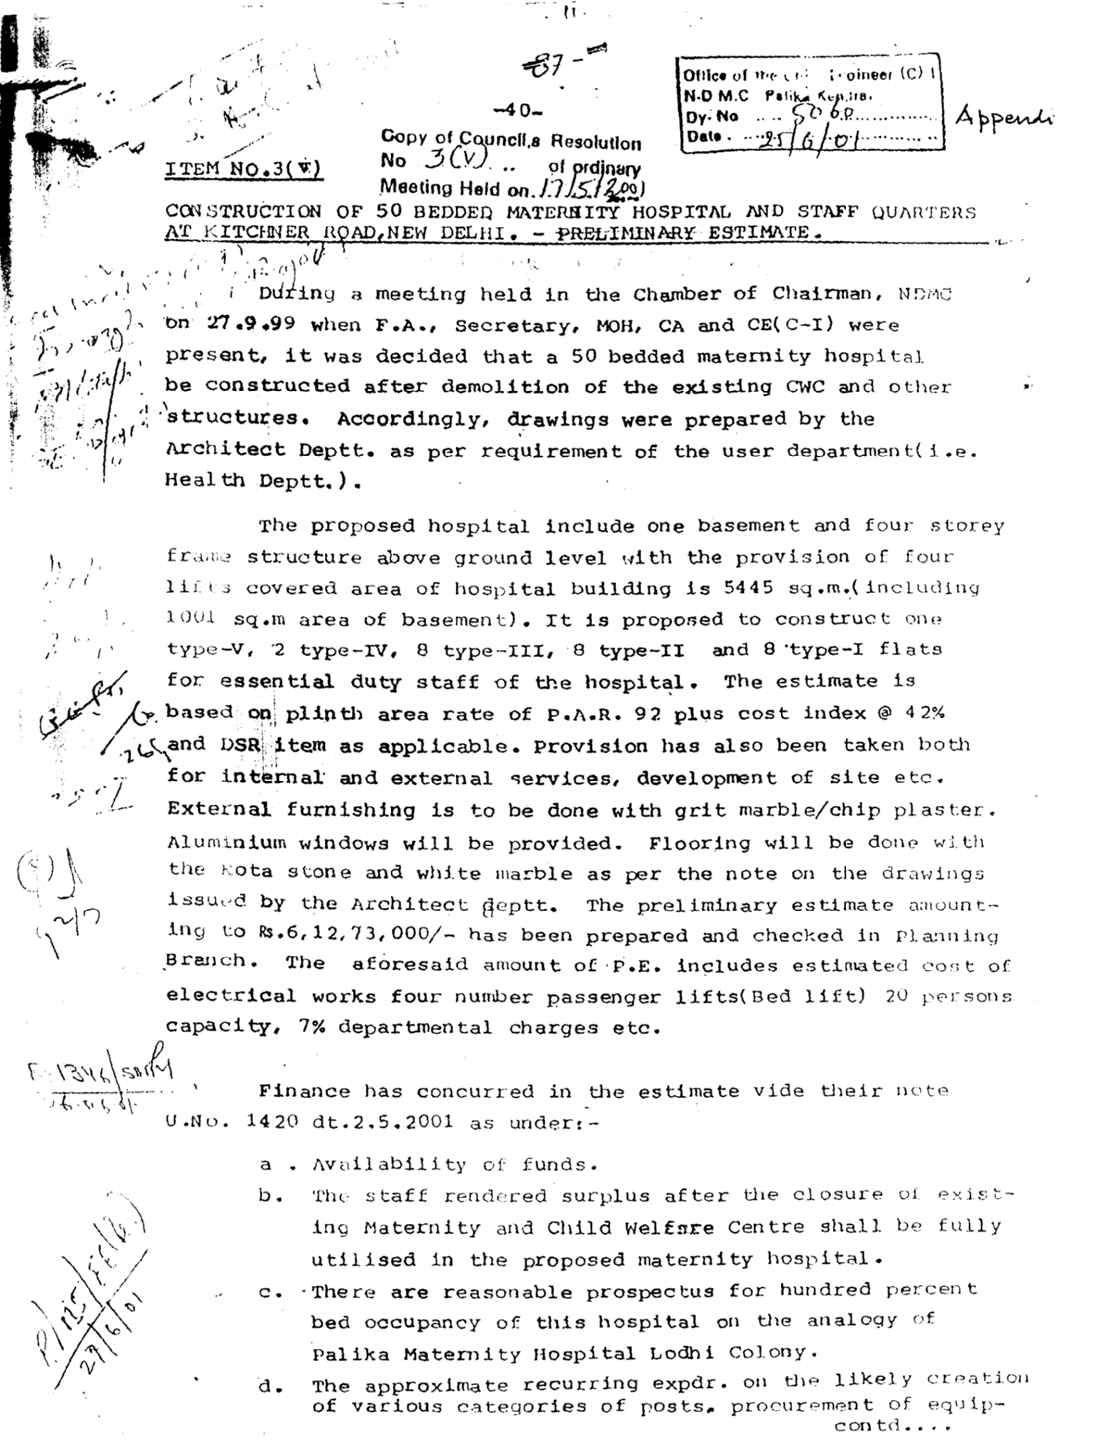

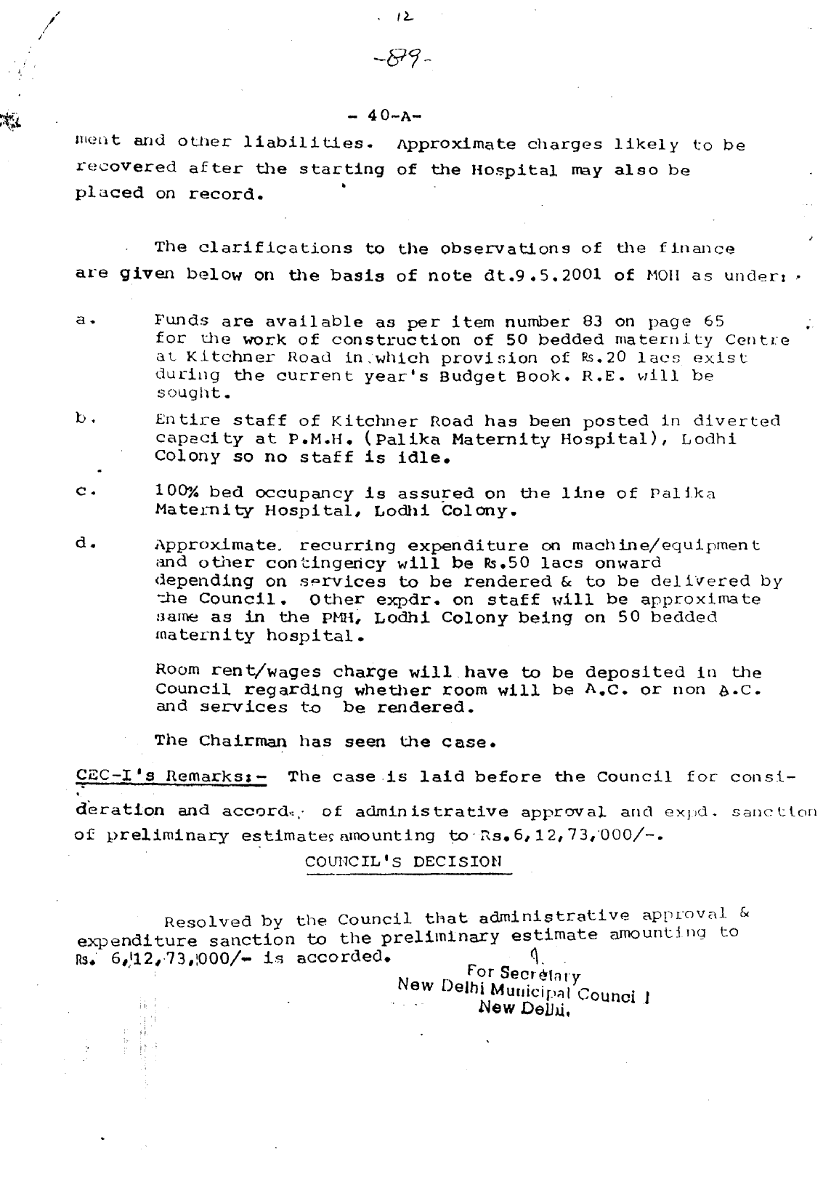

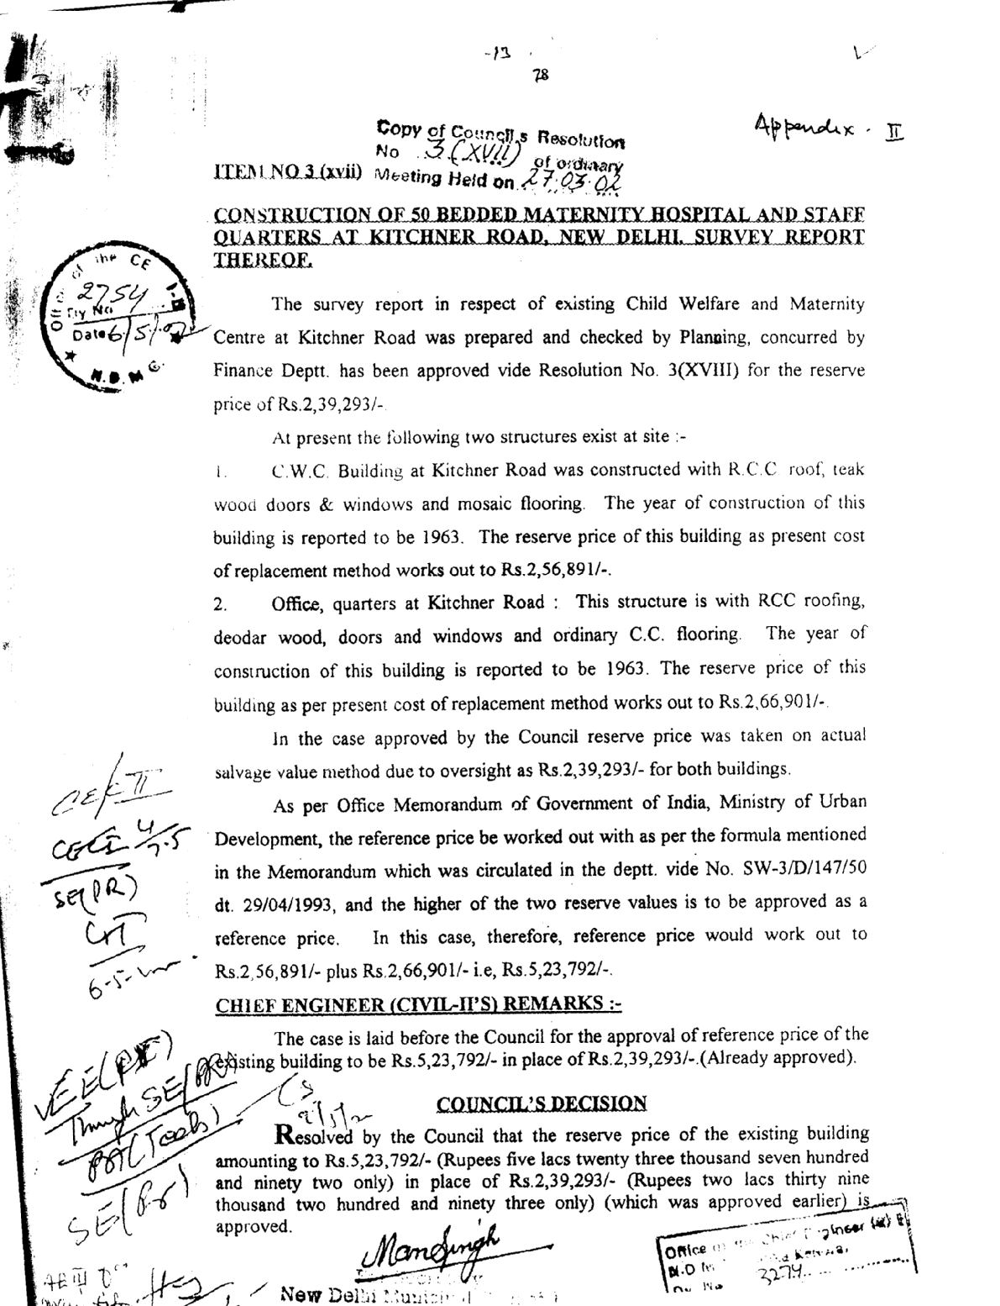

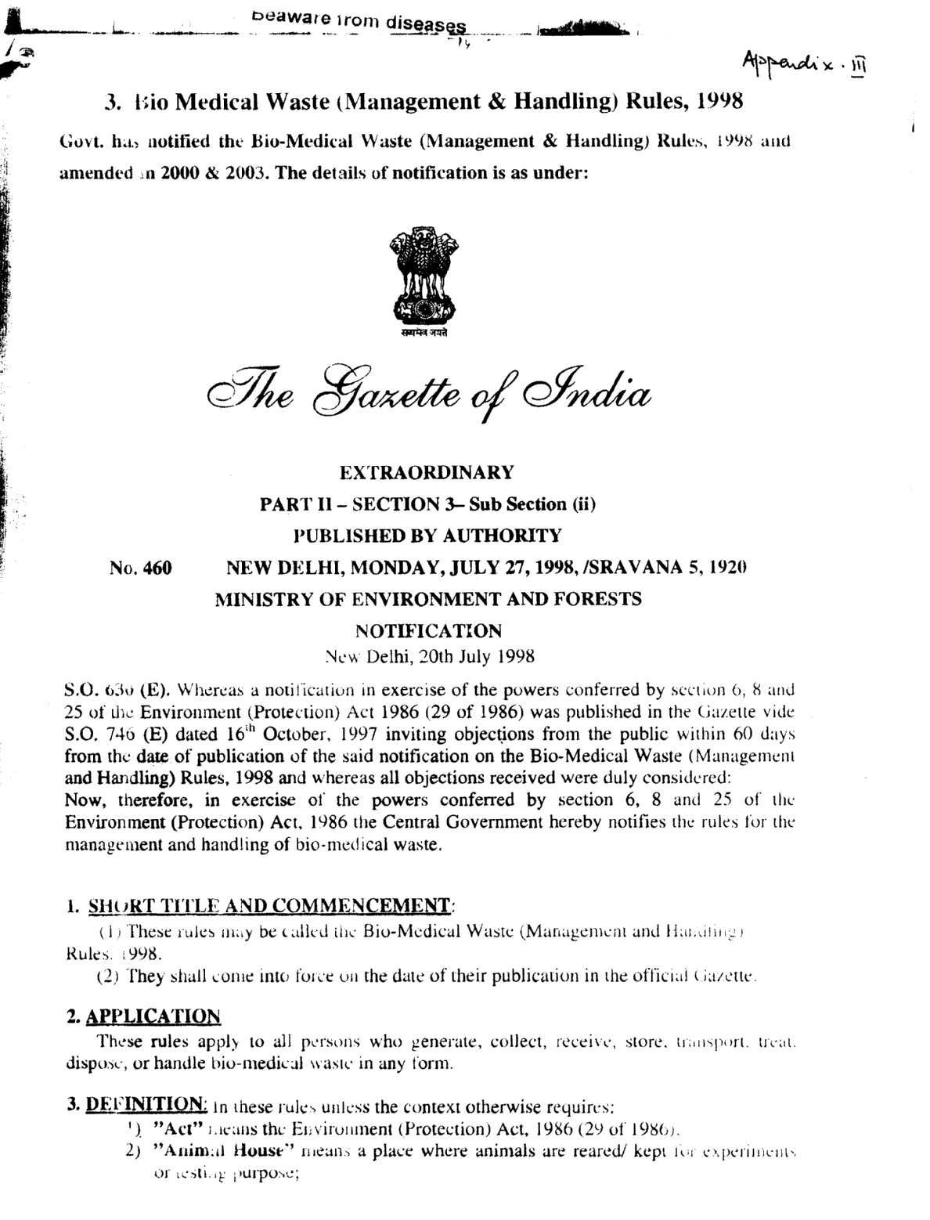

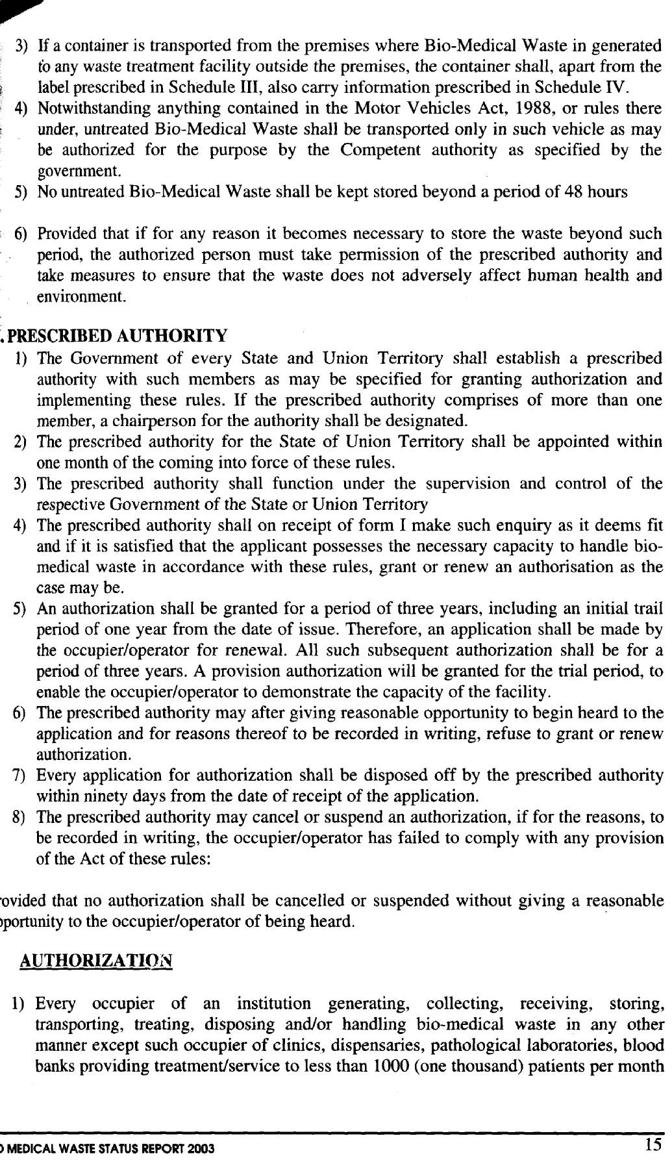
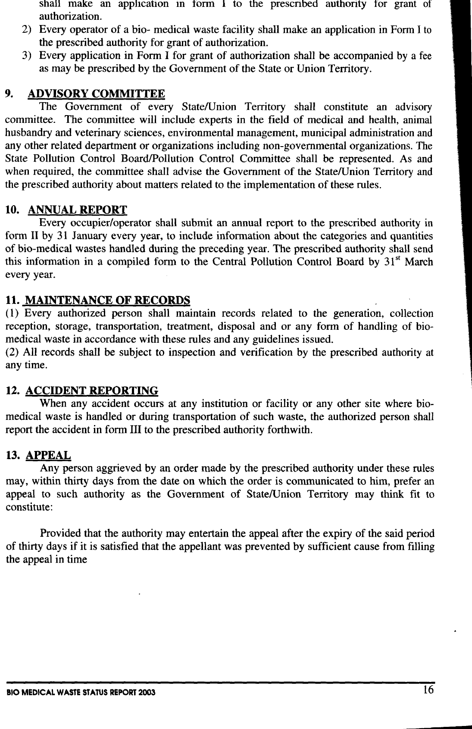

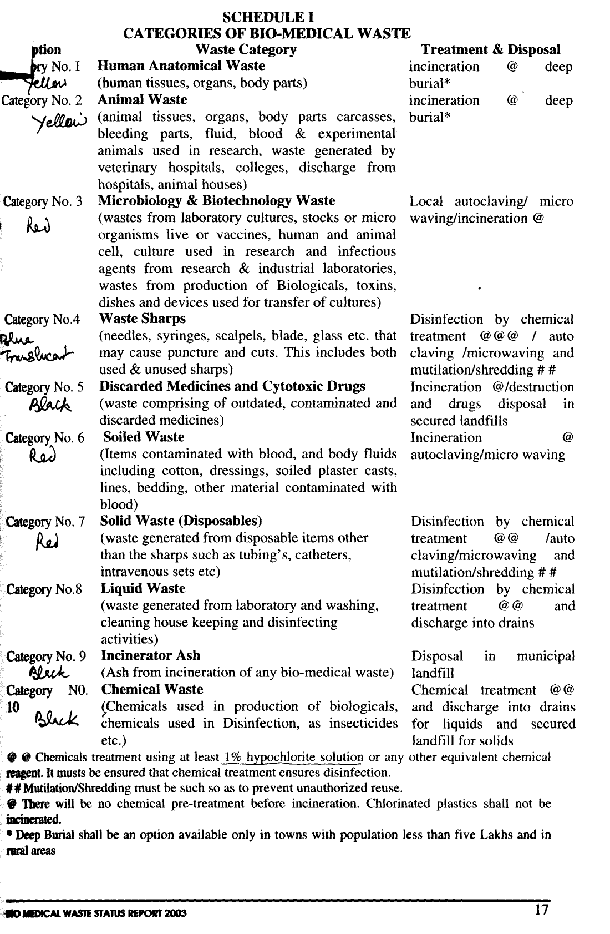
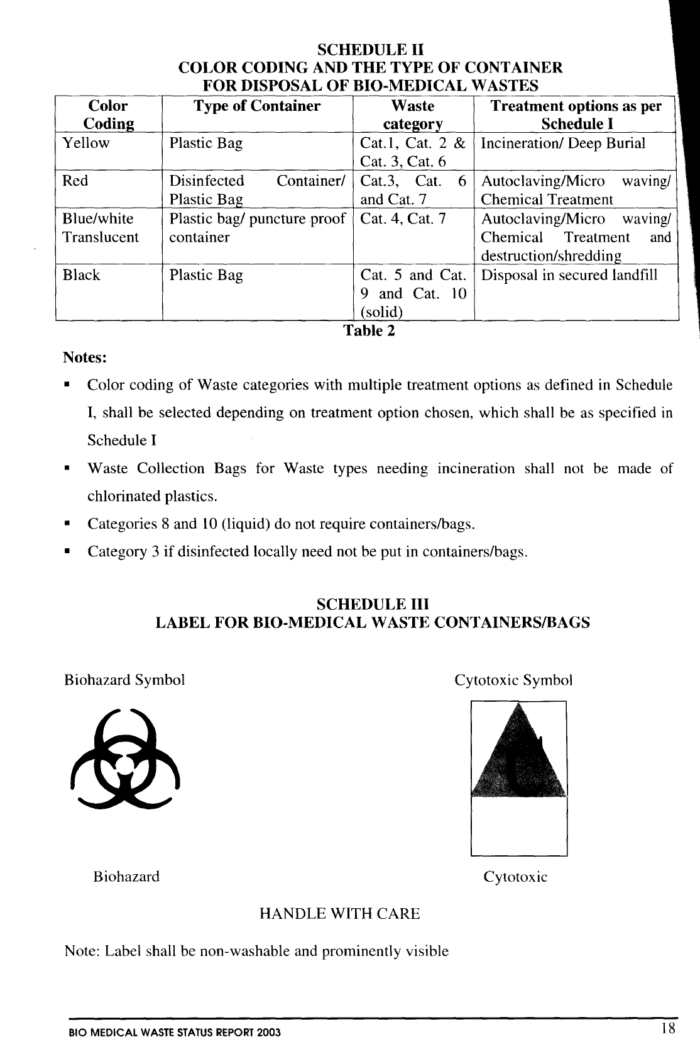
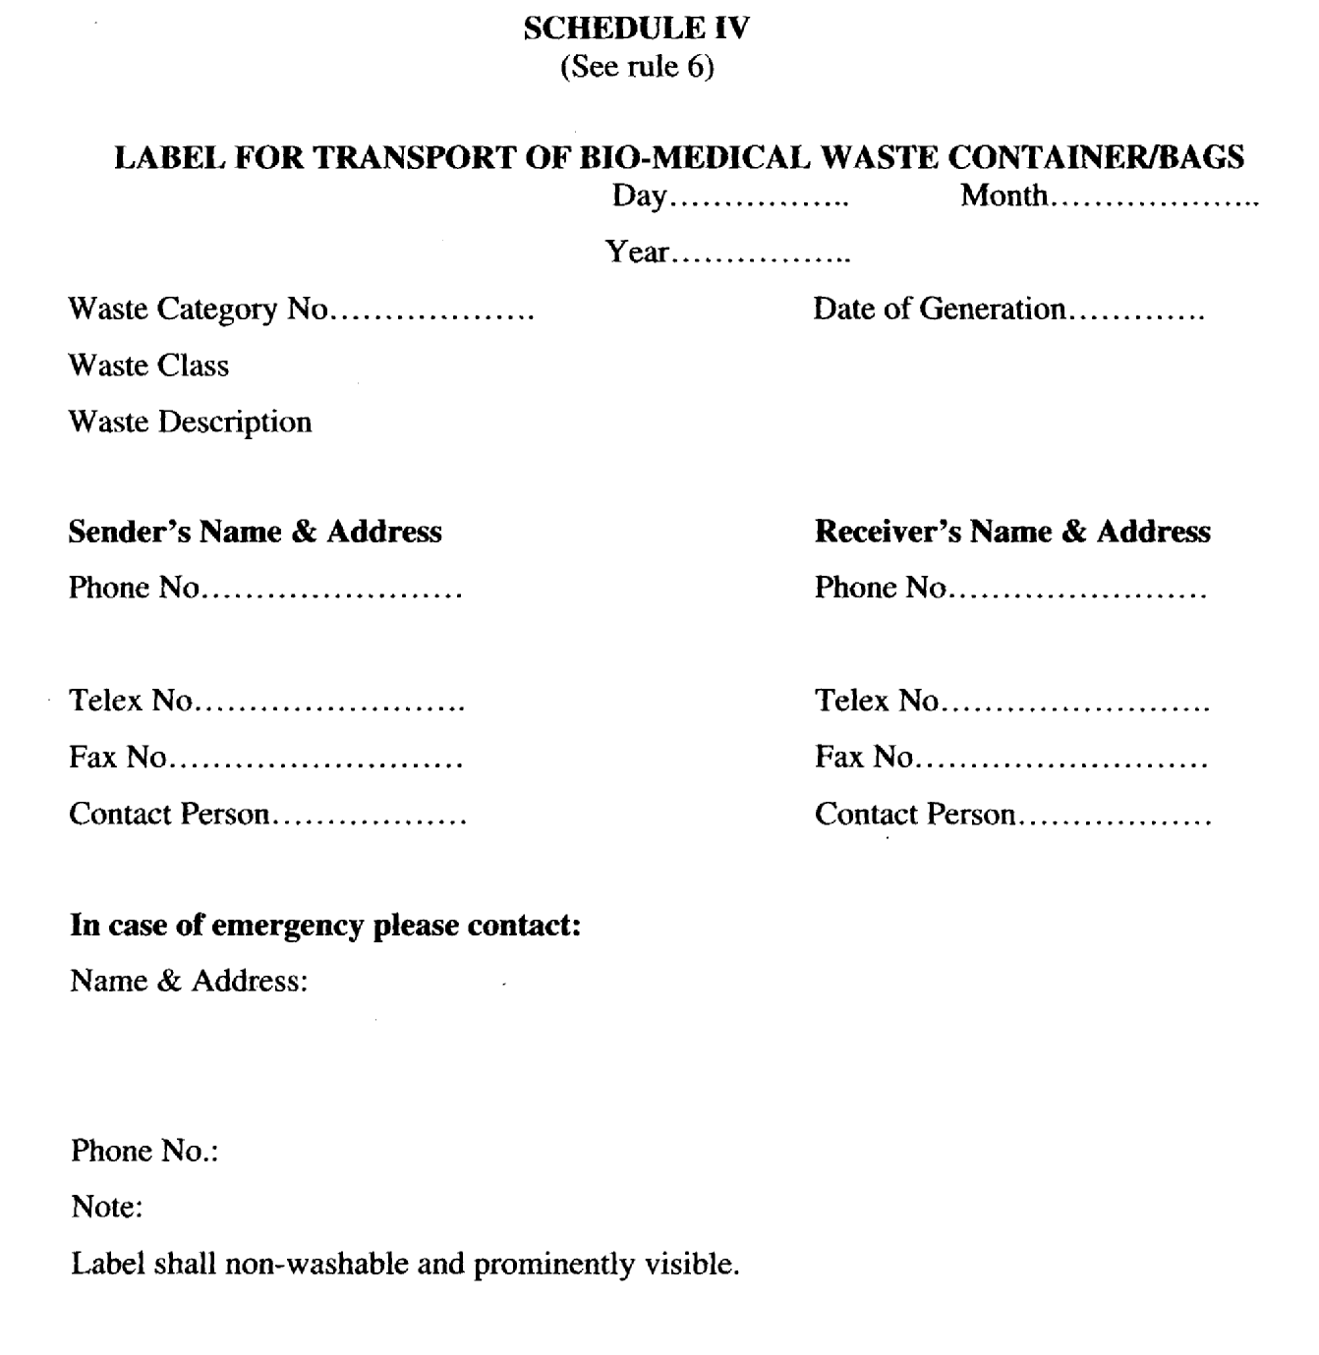

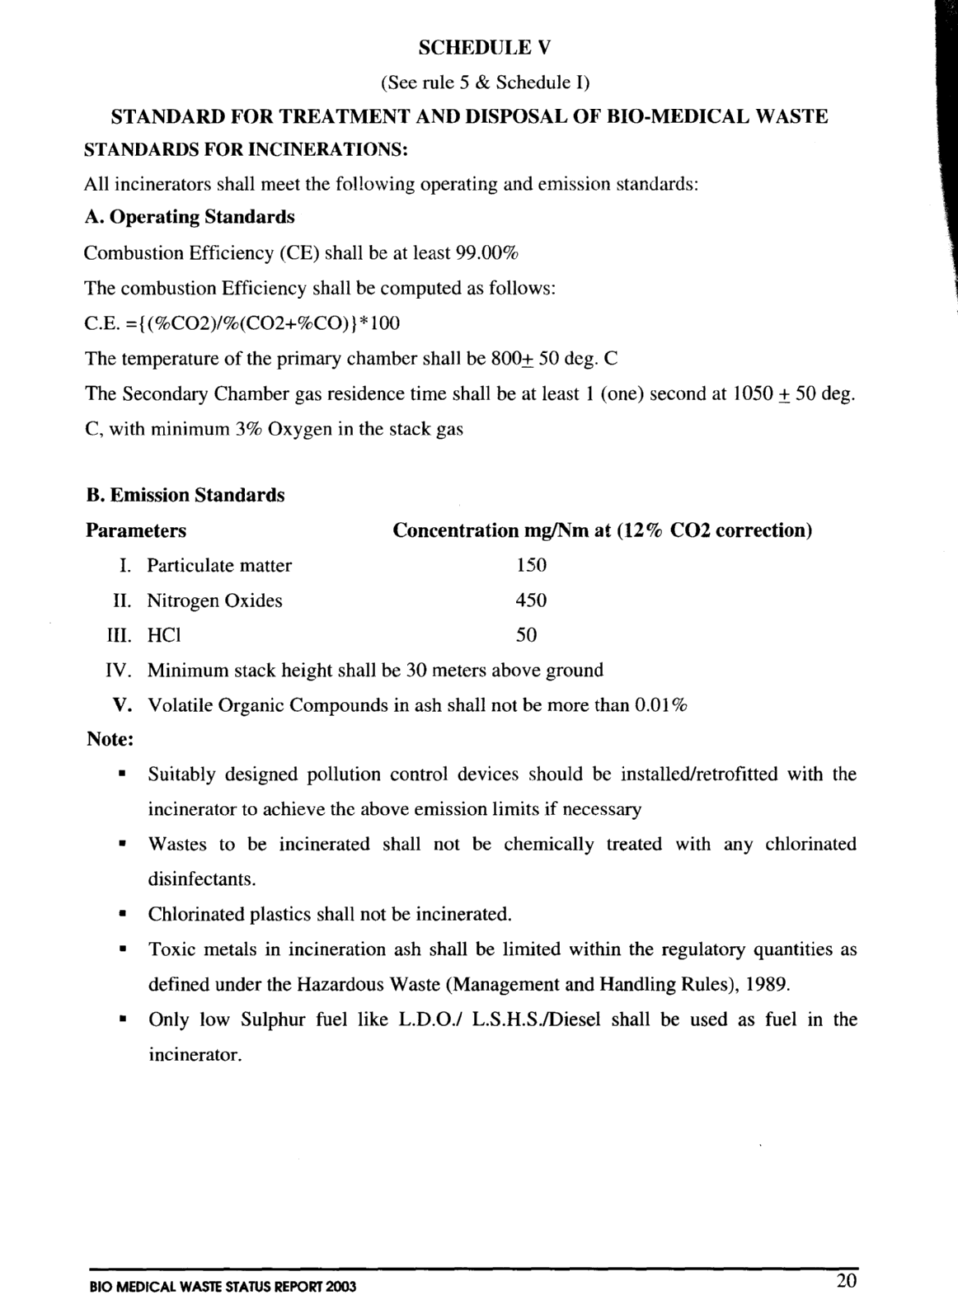

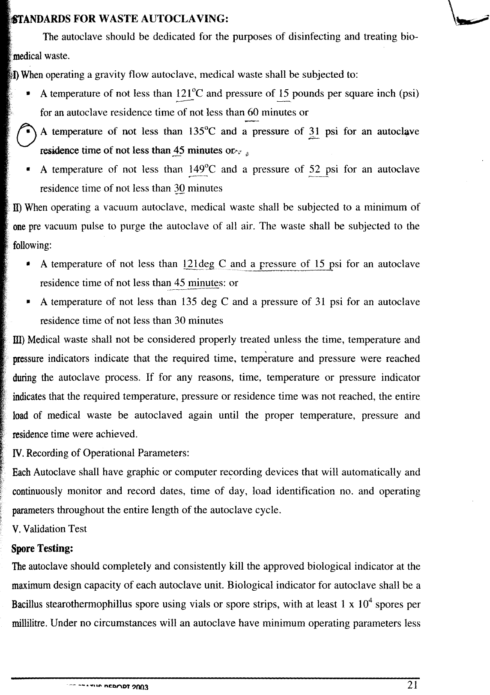

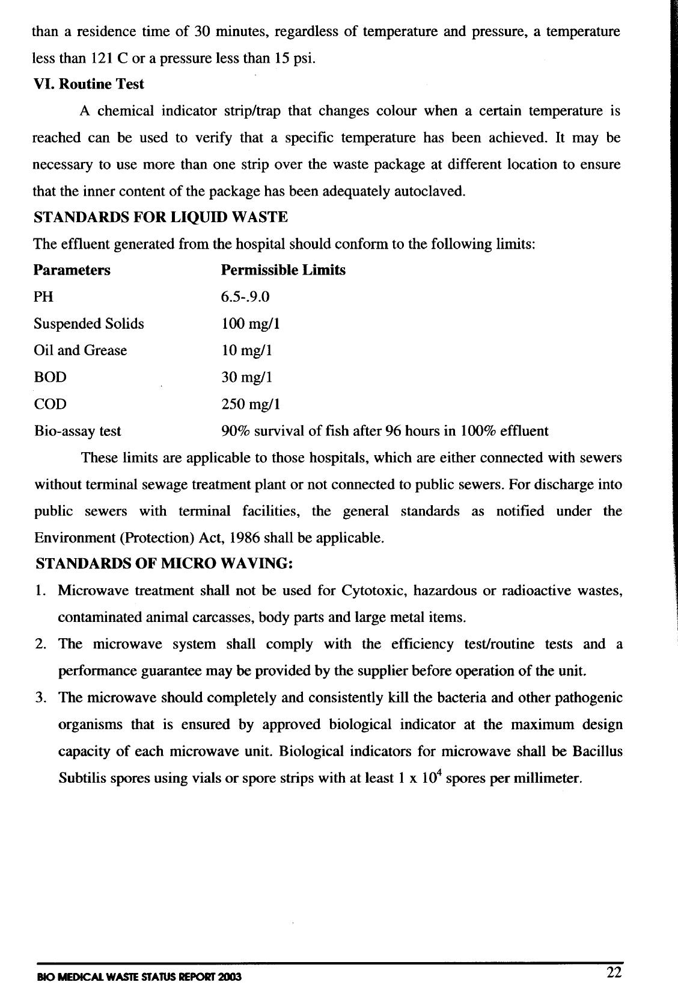

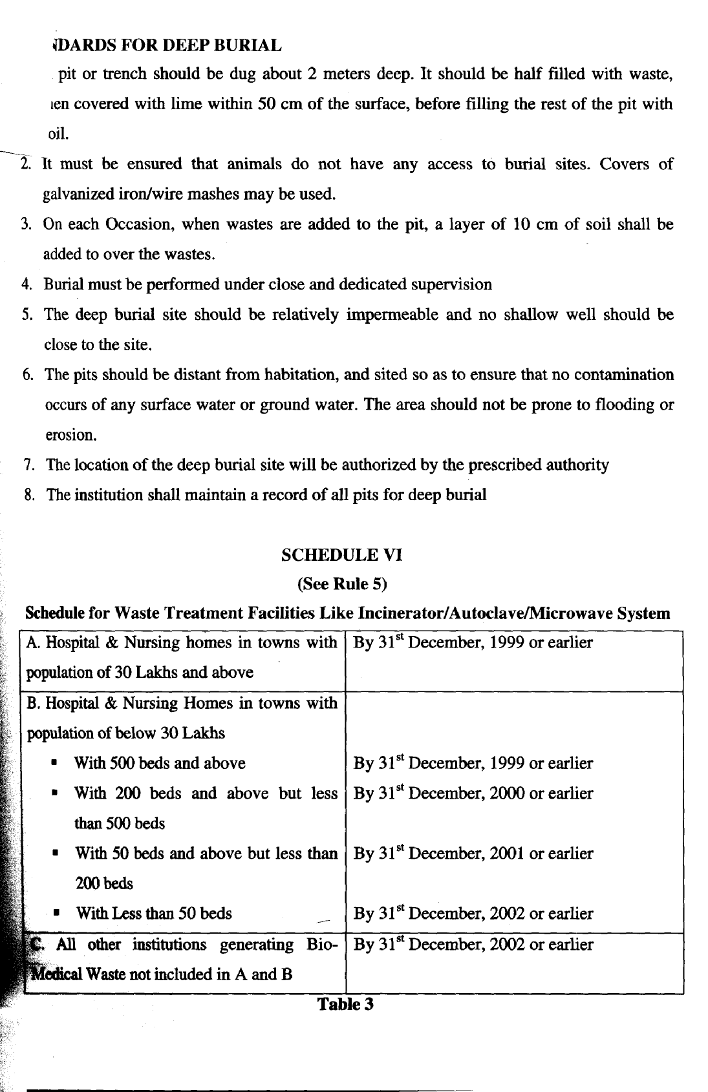


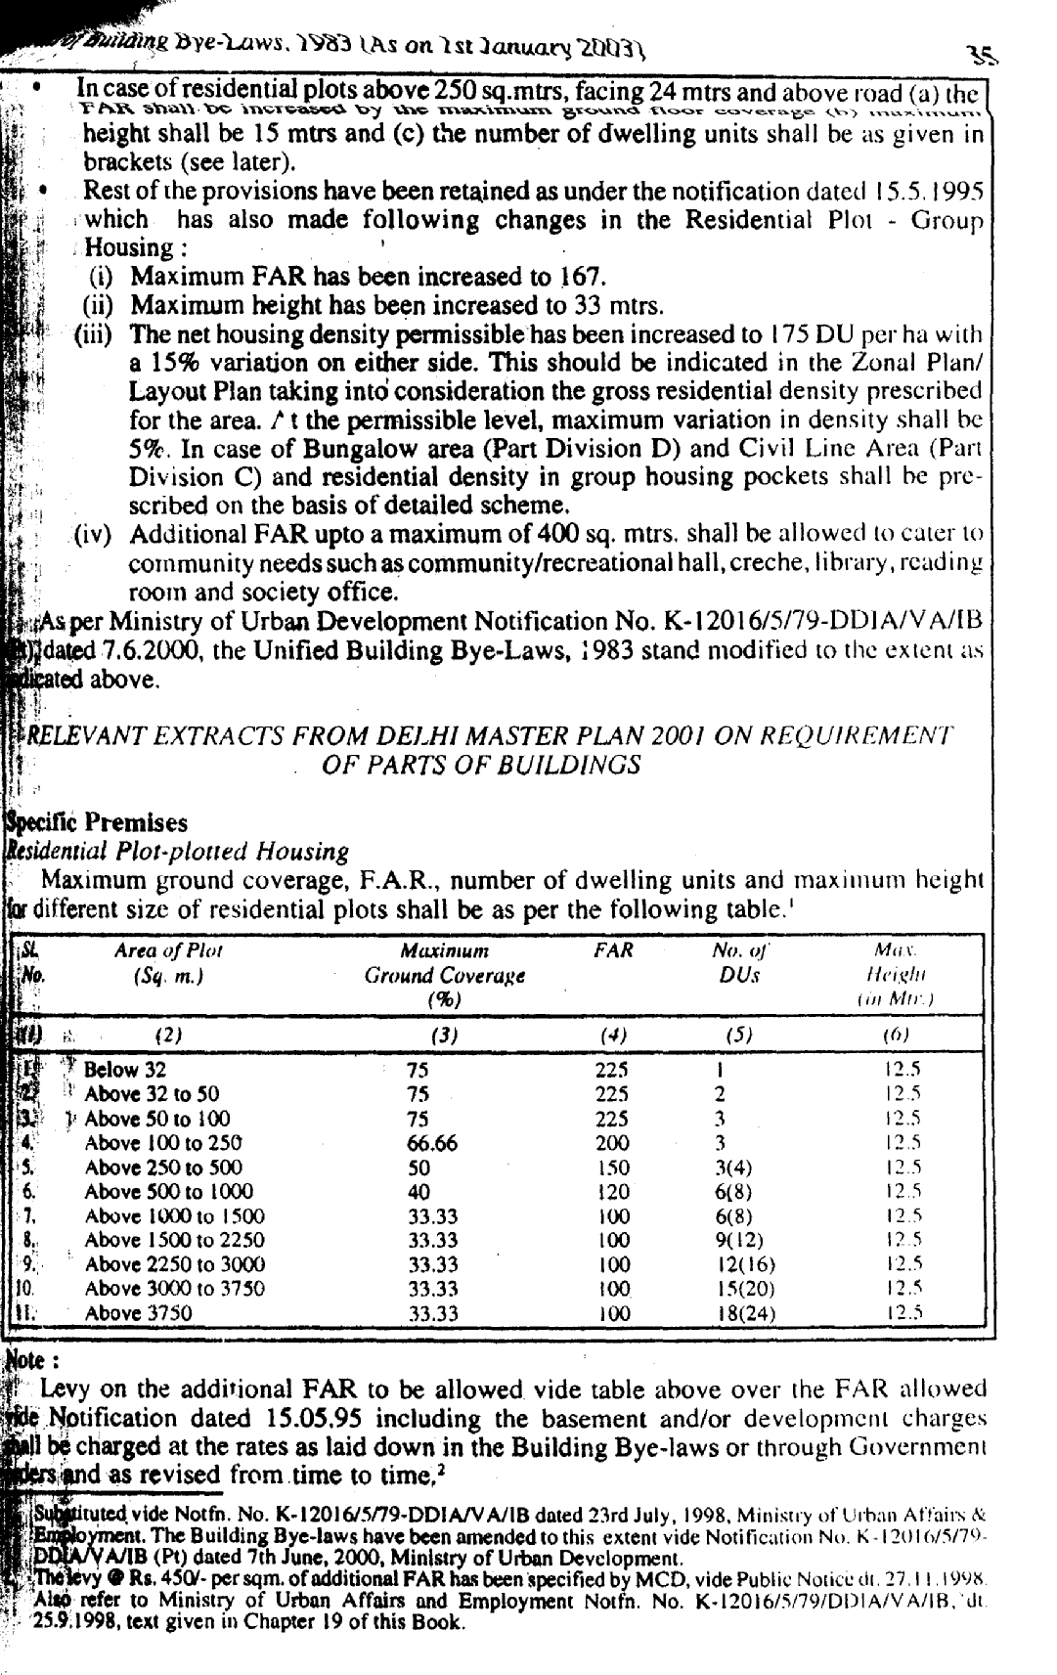

item no 6 (a-25)

1. Name of the subject/project : S/R of roads in NDMC area.
Sub-Head:Resurfacing of colony roads by lanes/service road by providing 2.5 cm thick dense graded asphaltic concrete in Moti Bagh, Sarojini Nagar, Nauroji Nagar, Netaji Nagar & Laxmi Bai Nagar area.

2. Name of Department : Civil Engineering Department
Roads-III Division.

3. Brief History of the subject/project : The lanes/by lanes, service roads were last resurfaced during the year 1998-99 at most of the places the condition of the roads are depilated. As per direction of the SE(R-I) the survey of the roads was carried out by the Field Engineers and found that the condition is very bad. More over the existing bitumen surface has already served its life of 5 years. The Preliminary Estimate was prepared for left out service roads which falls under the jurisdiction of (R-III) division. The Preliminary Estimate amounting to Rs.64,44,300/- lacs duly checked /concurred by Planning and Finance, respectively. Thereafter A/A & E/S amounting to Rs. 64,44,300/- was granted by the council vide council Reso. No. V(A-VI) date 27.05.2006.

The first call of tender was invited on 18.07.05. The lowest tenderer amounting to Rs. 53,67,666/- of M/s. Mehta Const. Co. was 15.81% of the estimated cost of Rs. 43,34,801/-. The tender was rejected by the Chairperson on 26.12.05 due to non fulfillment of the eligibility criteria. The tenders were re-invited after giving wide publicity through Press Notice which was published on 16th May 2006 in the Hindustan Times and NDMC / Delhi Govt. website. The tender was opened on 05.06.06. One downloaded tender document from the website and had put it in the tender box as per detail below

S.No. Name of Agency Estimated Rate quoted Tender
Cost amount
1. Dhingra
Construction Co. Rs. 46,34,801/- 75.54% above Rs. 81,35,841/-

The justification of rates is 92.32% above the estimated cost as securitized in planning on the basis of circulated/approved market rates.

After concurrence of the Finance Department and recommendation of the E-in-C the Chairperson, NDMC has given her acceptance of single tender in favour of M/s. Dhingra Const. @ of 75.54% above the estimated cost of Rs.46,34,801/- at tendered amount of Rs. 81,35,841/- with the permission to start the work in anticipation of acceptance of the tender by the Council because the validity of tender was upto 02.09.06.

Accordingly, letter of award to M/s Dhingra Construction Co. has been issued vide No. EE(R-III)/AB/A-I/D-1962-70 dated 30.08.06 and case is being placed before the council for its approval.

4. Detailed proposal on the subject/project :25 mm thick dense graded asphaltic concrete surfacing course using stone aggregate, stone dust lime stone dust and 60/70 grade bitumen to achieve a density of 2.338gm/cc with 5.20% bitumen after applying a tack coat with bitumen emulsion complying with IS:8887-1995 at the rate of @0.25 kg per square meter.

5. Financial implication of the proposed project/subject:The tendered amount of M/s Dhingra Construction Co. the only tenderer works out to Rs. 81,35,841/-. The necessary funds are available to meet the expenditure of this work during the current year budget provision of Rs. 1500 lacs exists vide item No. 239page No. 110 under the Head of Account G.1.3 of S/R of NDMC roads.

6. Implementation schedule with timeliness for each stage including internal processing :-The internal procedures for award of work have already been completed. After approval of lowest tenders by the Chairperson the letter of award issued to the contractor to commence the work. The work shall be commenced after approval of job mix formula from CRRI/ STH & Delhi PWD or any other Government approved Laboratory, and the time period required for the completion of the entire work is two months.

7. Comments of the Finance Department on the subject:-
FA observed as under:-

In the last para of note at ‘x’ P.84/n, is reproduced as : “Now coming to the tender case, if despite the fact that there is only one offer without any competition & there being no trend of rates except the rate a which R-I & R-IV has awarded the works in the recent past which are also from the same firm out of single offer, department has no other option but to accept the offer, placing on record details of the case the matter may be submitted to the competent authority for acceptance. It is however, felt that to avoid such tight situation department may also steps with a view to have the benefit of competitive rates for example the recorpeting work of lanes/service roads where response remains poor can be considered for merging with works on roads in the vicinity of lanes, besides working on conversion of roads into C.C. roads in a phased manner”.

We have already advised the department that if there is no other option but to accept the offer, in the light of circumstances of the case being brought out of the department, the matter may be submitted to the competent authority for acceptance. On the face of this and also considering the fact that the validity is going to expire on 02.09.06, department may process the case further for the approval of single offer by the competent authority, explaining the details of the case. Rest of the points like CC road / lane may be taken up for decision of the competent authority separately, through Detailed Project Report and need not to hold up the present tender

8. Comments of the Department on comments of Finance Department:
The quoted rates offered by the lowest contractor for the resurfacing of the back lane/ by lanes in various divisions are competitive and are below the justification of the rates as noticed in five divisions as given below:-

Division | % age of Tendered Rate over estimated cost | Justification Rate | % age of tendered rates with respect to justified rate | Duration (period) of Tender open on
R-I | 42.64% above | 62.71% above | 12.39% below | Feb-2006
R-II | 58.09% | 80.44% | 12.4% below | April-06
R-III | 75.54% above | 92.32% above | 8.72% below | June-2006
R-IV | 54.79% above | 64.70% above | 6.02% below | March-2006
R-V | 17.74% | -- | --- | Dec-05

As per the trend in other organisation are concerned, it is to submit that the standard of quality vary from the department to department which can not be compared. Moreover the proposed item 25mm BC are not being executed in P.W.D. they use 40-50mm DBM/BC only.

Regarding the response to the tender, it has been clarified that NDMC is very quality cautious and the work in hand is to be executed in back lanes / by lanes, staggered locations where quantum / progress of the work can not be compared with respect to the quantum of work on main roads with the same machineries. Hence the firms do not prefer to execute the work in back lanes / by lanes. The present amount of the work is very mere in compare the work of roads and investment of T&P.

Therefore inspite of single tender the quoted rates are well below the justified rates. The increase in the rates of the as compared to the last years only due to increase in the rates of bitumen such as bitumen was in the range of Rs.14,000/- per MT in the fourth quarter of the last year and the Rs.23,000/- per MT in July 2006 and Rs.24,643/- in August 2006. In the present case, single tender had met all eligibility criteria stipulated as per NIT.

With regards the much costlier concrete roads and huge cost involvement in conversion and other site constraint in NDMC area, the case was framed. At the tender stage change of scope etc. have no meaning for research when every delay cost to council heavily due to vertical increase trend. Moreover, the aspect of concrete roads was not accepted/ recommended by CRRI & DND evaluation for RIP and are not being used in most of the big project of roads costing multi Crores of NHAI even on BOT basis.

In regards the present tender, the quoted rates of single contractor are reasonable/ lower than justified rate and recommended for acceptance in the interest of council. Merging of by lanes and services roads with the main roads are not possible due to technical reason as well as the scope of items in main roads. Now the finance department may considered or reject the tenders. There are more chance to receive higher rate in next tender and re-tender are not advisable in such a circumstances.

The conversation of the roads into cement roads was not accepted due to technical ground and also not recommended in the CRRI in the case of main road.

9. Legal implication of the subject/project:- Nil

10. Details of previous Council Reso. Existing law of Parliament and Assembly on the subject: The administrative approval and expenditure sanction of this work was approved amounting to Rs. 64,44,300/- by the council vide council Reso. No. V(A-VI) date 27.05.2006.

11. Comments of Law Department on the subject : No Comments

12. Comments of the Department on the
comments of the Law Department : Not applicable

13. Recommendations : The case is laid before the Council for approval of action taken, to award the work and to accept the offer of M/s Dhingra const. Co. at 75.54% above the estimated cost of Rs. 46,34,801/-. The tendered amount works out to Rs. 81,35,841/- (Rs. Eighty one lacs thirty five thousand eight hundred forty one only) and to accord revised A/A and E/S for amounting to Rs. 81,35,841/- + 5% contingencies = Rs. 85,42,633/- (Rupees Eighty five lacs forty two thousand six hundred thirty three only) for the work of S/R of roads in NDMC area. SH:- Resurfacing of colony roads, service roads, lanes by lanes 2.5 cm thick dense graded asphaltic concrete in Moti Bagh, Sarojini Nagar, Nauroji Nagar, Netaji Nagar & Laxmi Bai Nagar.

COUNCIL DECISION

Resolved by the Council that approval for revised AA & ES for amounting to Rs.81.35,841/- + 5% contingencies = Rs.85,42,633/- is accorded for the work of S/R of roads in NDMC area.

ITEM NO.7 (M-6)

- Name of the Subject/Project: Outsourcing for Leasing of Computer
Hardware, Software & connected accessories and providing manpower for imparting of computer education in NDMC/Navyug Schools.

- Name of the Deptt. : Education Deptt. NDMC.

- Brief History of the project: NDMC is imparting computer education as an awareness cum learning of computers from class VI to X and as a subject Computer Science & Informatics Practices in classes XI & XII. There are 16 labs in NDMC (6 Sr. Sec. + 9 Sec. + 3 Middle) Schools and 5 labs in Navyug Schools. (May like refer the details as per Annexure)(See pages 81 – 83). To cover all Middle schools 8 more labs were constructed of which 7 are in NDMC Middle Schools & 1 in Navyug Secondary School Vinay Marg. To equip these 8 computer labs a proposal for the procurement of 162 computers and the expenditure was amounting to Rs.72.0 lacs approx. was placed as an agenda item no.3(M-4) before the Council in the Council Meeting held on 21.6.06 for approval. The Council deferred the Agenda and suggested that deptt. should examine the option of outsourcing school labs with Hardware and manpower on the same line as adopted by Dir. School Edn. GNCTD. Accordingly the case has been taken up by the deptt. and is resubmitted for consideration.

4. Detailed proposal on the subject/project:
(i) Proposal of Hardware Procurement as per requirement given below :

Item | Quantity | Configuration
PC | 130 (15 computers in 8 labs + 10 computers for the extension of Computer Lab of Bengali School ) | PIV 670 (3.8 GHz, 2MB L2 Cache, 800-MHz front side bus) or PD 950 (3.4 Ghz, 2x2MB L2 Cache, 800-Mhz, Intel® 945G chipset , 2 GB DDR2 SDRAM PC2-5300 (667-MHz) Non-ECC, 80 GB normal 1.5Gb/s Hard Drive (7200 rpm), ATI RADEON X300 SE PCI Express 128-MB DDR, PS/2 or USB Standard Keyboard/mouse
Printer | 8 | HP LaserJet 5100 22ppm wide-format monochrome laser printer, 16MB RAM; 250-sheet feeder standard & 100-sheet multi-purpose tray
UPS | 130 (Stand alone) | Luminous 800 VA 20-25 min backup approx.
Modem | 08 | Tri Band/Broad band connection with 500 mbps speed
Window | 130 (Licenses) | 2000 with License
MS Office | 130 (Licenses) | Office 2003 with license
LAN | - | Integrated Broad com Net X treme Gigabit Ethernet or  Intel Pro 1000 MT Gigabit NIC (full height)

(ii) Proposal for Manpower :

Informatics Practices as an Elective subject is being taught in 4 Sr. Sec. Schools of NDMC for which 4 Lecturers are required and are being recruited on contract basis. In addition to this Computer as an Awareness Course is being taught in all 23 ( 16 existing + 7 new) schools for which a TGTs are also recruited on contract basis. The requirement of 18 TGTs to be appointed on regular basis have been sent to DSSSB during the year 2002. The exam has been conducted by DSSSB for this regular appointment but no panel has been received in this office to fill these post till date. Therefore, the service provider would provide 4 Lecturers & 23 TGTs to NDMC schools to impart Computer Education to children.

- Financial implication of the project: The financial implication has been calculated on the basis of the information received from GNCT, Delhi which has introduced the concept of outsourcing for the year 2000-04 under CEP-I (Computer Education Programme) covering 159 schools. Again for the year 2002-2005 CEP-II was launched in which 275 schools have been covered. Again for the year 2004-08 CEP-III was started covering 635 schools. The contract of CEP-I was renewed during 2005 and for the year 2006 – 2010 the contract of CEP-II have been renewed. This process of renewal is taken after the termination of the initial contract. Till date so far 1069 schools have been covered under this scheme. The tender document published by GNCT, Delhi have also been referred while preparing the tender document being published by NDMC. As per information received from GNCT, Delhi, the cost for 1 computer lab to provide 10 computers and a teacher has come out to be Rs.15.0 lac for 4 years. The total cost of Hardware at the same rate of Rs.15.0 lac for 9 labs and the provision of teacher in all 23 NDMC schools comes out to be Rs.1.35 crore.

After the finalization of L1 bidder the work order will be given to the bidder and agreement will be signed. After signing of the agreement the bidder will be given 30 days for the installation of the Hardware in the labs and after having received the satisfactory report of the installation from the Head of the School, 15% of the bid amount will be released on the invoice received from the bidder. The balance 85% of the total payment will be evenly distributed in 8 installments. First installment will be paid after elapsing 6 months from the date of commissioning of the Hardware and thereafter every six months next installment will be given.

The comparison of the cost with earlier proposal where the deptt. was purchasing Hardware and was recruiting contractual teacher and the cost of outsourcing is given as under :-

- Hardware cost – Rs.72.0 lacs (to be purchased by NDMC)
- Cost of manpower for 4 years

Post | No. | Salary per month per person | Salary per annum per person | Total Salary for 4 yrs.
PGT | 4 | Rs.16000/- | Rs.1.92 lac | Rs.30.72 lacs
TGT | 23 | Rs.13000/- | Rs.1.56 lac | Rs.1.44crore
Grand Total |  |  |  | Rs.1.75 crore approx.

Hardware cost | Rs.72.0 lacs
Salary of Teachers for 4 yrs. | Rs.1.75 crore approx.
Total cost for 4 yrs. By purchasing hardware & hiring teachers | Rs.2.47 crore

So, the comparison shows that the outsourcing of H/W and Faculty is a better and a cheaper option.

- Implementation schedule with timelines for each stage including internal processing:
The expected time for implementation would be six months which would include publishing of NIT, Submission of bids, evaluation of bids, finalization of contract, signing of contract and agreement, commissioning and installation of Hardware.

- Comments of the Finance deptt. on the subject:
  - The procedure as envisaged in GFR-2005, Rules 179 to 185(pages 60 and 61 of Swami’s compilation of GFR 2005) is adopted.
  - Data and information and computations are correct; and
  - Approval of the competent authority is obtained.

- Comments of the deptt on comments of Finance deptt. : The department would adhere to all instructions/observations of the Finance Department while dealing with the tender document.

- Legal implication of the subject : The tender document has been vetted by Law Deptt.

- Details of previous Council Resolutions, existing law of Parliament and Assembly on the subject. : Nil

- Comments of the law Deptt. on the subject: Not applicable.

- Comments of the deptt. on the comments of Law Deptt. : Not Applicable.

- Recommendation: It is recommended that the outsourcing for lease of computer hardware and connected accessories along with provision of 4 lecturer and 23 TGTs may be approved for 4 yrs.

- Draft Resolution: The Council approves Outsourcing for Leasing of Computer Hardware, Software & connected accessories and providing manpower for imparting of computer education in NDMC/Navyug Schools.

COUNCIL’S DECISION

Resolved by the Council that leasing of Computer Hardware, Software & connected accessories and providing manpower for imparting of computer education in NDMC/Navyug Schools be outsourced.

Further resolved by the Council that the requirement of 18 TGTs earlier sent to DSSSB withdrawn.

ANNEXURE
S. No. | Name of school | No. of computer  available | Utilization of computer room class wise | Teacher/Requirement
1 | NP Girls Sec. School Havlock Square | 8 | IV – 3  V – 3  VI – 4  VII – 4  VIII – 4  IX –4  X –2  Total= 24 Pds. | Sh. Sudhir Saini, Asstt. Tr. working on deputation
2 | NP Bengali Girls Sr.Sec.School Gole Mkt. | 13 | VI- 9  VII- 9  VIII- 9  IX-7  X-7  Total= 41 Pds. | P.G.T Vacant  T.G.T Vacant
3 | NP Girls middle School Gole Mkt. | 16 | III – 3  IV- 2  V- 2  VI- 6  VII- 6  VIII- 6  Total= 25 Pds. | Sh. R.K. Yadav, Asstt. Tr. working on deputation
4 | NP Girls Sr. Sec. Gole Mkt. | 22 | XI-10  XII-12  XII-13  Total=35 Pds | Sh. Vijay Kumar, TGT  PGT vacant
5 | NP Boys Sr. Sec Mandir Marg. | 42 | VI - 6  VII - 6  VIII- 6  IX - 12  X - 06  Total = 36 Pds | Sh. Rahul Nogia, TGT  PGT vacant
6 | Navyug School Peshwa Road | 22 | XI-18  XII-18  Total=36 | Mrs. Sheetal Gupta,PGT  TGT vacant
7 | NP Co-ed Middle School Kitchner Road | 20 | III – 3  IV- 2  V- 2  VI- 6  VII- 6  VIII- 6  Total= 25 Pds. | TGT Vacant
8 | N.P.Co-ed Sec. School Aurangzeb Lane | 18 | VI-8  VII-6  VIII-8  IX-4  X-4  Total=30 Pds | TGT Vacant
9 | NP Co-ed Sr.Sec. School Ansari Nagar | 13 | VI-3  VII-2  VIII-2  IX-2  X-2  XI-10  XII-10  Total=31 Pds | Sh. Anuj Kumar, PGT  TGT Vacant
10 | NP Co-ed Sr. Sec. School Moti Bagh | 13 | VI-6  VII-6  VIII-6  IX-4  X-4  XI – 4  XII - 4  Total=34 Pds | Mrs. Renu, TGT
11 | N.P Co-ed Sec. School Laxmi Bai Nagar | 12 | III – 2  IV- 2  V- 2  VI- 6  VII- 6  VIII- 6  IX – 4  X - 4  Total= 32 Pds. | TGT Vacant
12 | Navyug School Sarojani Nagar | 20 | VI-3  VII-3  VIII-3  IX-3  X-3  XI-11  XII-11  Total=37 Pds | Sh. M.D. Irfan (PGT)  Sh. Sudhanshu Gupta(TGT)
13 | Navyug School Moti Bagh | 13 | IX-4  X- 4  XI-18  XII 18  Total= 44 Pds | Mrs. Rachna Khatri,TGT  PGT Vacant
14 | Navyug School Vinay Marg | 1 |  | Mrs. Lata Nayer,TGT
15 | Navyug School  Laxmibai Nagar | 21 | XI-17  XII-17  Total=34 Pds | Ms. Anuradha,PGT  TGT required
16 | NP Boys Sec. Bapu Dham | 13 | IV – 4  V - 4  VI- 3  VII- 3  VIII-3  IX- 6  X- 6  Total=29 Pds | TGT Vacant (Ist shift)  Sh.Rajnish,TGT(IInd shift)
17 | N.P Co-ed Sec. School Lodhi Estate. | 12 | VI-2  VII-4  VIII-6  IX-6  X-10  Total=28 Pds | TGT Vacant
18 | Navyug School Lodhi Road | 13 | VI-1 Math=7  VII-1  VIII-1  IX-2  X-3  XI-10  XII-10  Total=35Pds | Sh. Rahul Sultana,PGT  Sh. Sunil Kumar,TGT
19 | NP Boys Sec. School Balmiki Basti |  | Merged
20 | N P Co-ed Sec. School Tilak Marg | 11 | VI-10  VII-9  VIII-9  IX-4  X-4  Total-36 Pds. | Sh. Pankaj Kumar,TGT
21 | NP (G) Middle Lodhi Road | 12 | IV-6  V-6  VI-6  VII-4  VII4  Total-26 Pds. | Sh. Satish Singh,TGT

ITEM NO.8 (A-26)

1. Name of the Project:

Development of various Markets in NDMC area
SH: Façade Improvement for Janpath Road Berm Market (between Outer Circle and Tolstoy Marg)

2. Name of the Department concern:

Civil Engineering Department

3. Brief History of the Project:

Basically this Market consists 75 Nos. shops, out of which 42 shops have same area and 33 shops have different areas. Initially Architectural drawing was received from HUDCO (Housing & Urban Development Corporation Ltd.) in respect “Façade improvement for Janpath Road Berm Market (Between Outer Circle & Tolstoy Marg” with four options. Out of these options, option No.2 (as detailed opinion in scope of work) was approved after the concurrence of Market Shopkeepers Association, Janpath. Further, a joint inspection was conducted by the concerned officials of NDMC and Architects of HUDCO to ascertain the practical feasibility of the proposal at site as shown in the Architectural drawing. During inspection, several deficiencies were observed and brought to the notice of Senior Officers. Subsequently, Chairperson decided that Project to be taken up by Project Team with our own Architect for further modification and changes. Accordingly, a joint inspection was conducted by the Project Team to discuss deficiencies earlier noticed. Thereafter, a modified drawing with some minor changes was prepared and accordingly a Preliminary Estimate to implement the Façade Improvement work had been processed amounting to Rs.87.71 Lacs for accord of Administrative Approval and Expenditure Sanction by the Chairperson. P.E. has been duly concurred in by Finance & Empowered Committee. The expenditure is proposed to be charged to the Head of Account H.1.8/Item No.286 of the Budget Book for the year 2006-07.

4. Detailed proposal on the Subject / Project:

Preliminary Estimate amounting to Rs.87.71 lacs were framed for “Façade Improvement for Janpath Road Berm Market” will have the following scope of work:

•Top facia & partition walls with Alucobond.

•Uniform signages on Flex Sheet.

•Uniform show window in aluminium frame and 6mm toughened glass.

•Identical false ceiling for projected portion with aluminium sheet.

•Pedestrian work way to be finished with precast C.C. floor tiles.
•Construction of 2 Nos. Toilet Blocks on BOT basis for Tibeten Market & Janpath Market.

•Providing Street Furniture at various location in the market for Senior Citizens and other customers.
•Construction of One café/STD booth for disabled person.
•Providing Directional Sign Boards at various locations in the Market.

•Providing Cable Ducts to cope up with the enhancement of Electricity load, telephone and cable TV for shops without damaging the flooring and elevation.

5. Financial implications of the proposed Projects / Subject:

Preliminary cost of the Project is Rs.87.71 lacs.

6. Implementations schedule with timelines for each stage including internal processing:

P.E. amounting to Rs.87.71 lacs for accord of A/A & E/S by Chairperson - 31st August 2006
D.E. & NIT - 15th October 2006
Call of Tenders - 15th November 2006
Award of Work - 15th December 2006
Completion of work (5-1/2 months) - 31st May 2007

7. Comments of the Finance Department on the subject:

Finance Department have no objection to the P.E. amounting to Rs.87.71 lacs for the proposed work provided it is ensured and certified that

a. The character of these shops which is other than permanent does not change after execution of proposed work and the guidelines / orders, if any, issued by the Ministry of Urban Development in respect of these shops are not violated.

b. Licence fee is revised taking into account the cost to be incurred on improvement of the shops.

c. Sufficient funds are got approved for the scheme from the competent authority.

8. Comments of the Department on the comments of Finance Department:
CIVIL:

The expenditure is proposed to be charged to the Head of account H.1.8/Item No.296, wherein a provision of Rs.40 lacs exist in the budget book of the year 2006-07. The amount of expenditure is not expected to cross this limit during this financial year, however, sufficient funds shall be got approved for the scheme from the competent authority in due course as suggested by Finance Department.

ESTATE:

i. It is not a deposit work. Earlier it was a deposit work because HUDCO was implementing this Project and NDMC was depositing the money and now NDMC is the executing agency.

ii. Licence fee will be enhanced according to the expenditure incurred on this improvement and the enhancement will be made with the prior approval of the Finance Department.

iii. Regarding observation made about the improvement work in Momo Market, Shankar Market, Pandara Road Market, I would like to clarify that upgradation of Momo Market has been done recently and licence fee will be enhanced very soon and upgradation is done recently and information regarding Shankar Market and Pandara Road Market will be supplied in due course of time.

9. Legal implications of the Subject / Project:

- Not applicable -

10. Details of previous Council Resolution, existing law of Parliament & Assembly on the subject:

- Not applicable -

11. Comments of the Law Department on the Subject / Project:

Finance Department had raised observation about legal opinion from Legal Advisor to determine whether the scheme is covered under Section 334, 335 and 336 of the NDMC Act.

In respect of this L.A. is of the view:
The proposal is not covered under Section 334, 335 and 336 of the NDMC Act. The construction and maintenance of Municipal Markets and Regulation of all Markets is an obligatory function of NDMC. Janpath Road Berm Market is a Municipal Market and NDMC is an receipt of licence fee from the shops. Since the NDMC is not spending on maintenance and upkeep of the Market, the Markets are in bad shapes. The Council has, therefore, provided for Municipal Market Development. The expenditure is for improvement of the NDMC Market. It is not an improvement in private market.

Legally there is no bar and improvement of our own Market.

12. Comments of the Department on the comments of the Law Deptt.:

- Nil -

13. Recommendations:

P.E. amounting to Rs.87.71 lacs for Façade Improvement for Janpath Road Berm Market (between Outer Circle and Tolstoy Marg) approved by the Empowered Committee which was duly approved by Finance & E-in-C and is now recommended for accord of approval of the Council.

14. Draft Resolution:

Resolved by the Council that A/A & E/S is accorded for Preliminary Estimate amounting to Rs.87.71 lacs (Rs. Eighty Seven Lacs Seventy One Thousand Only) for Development of various Markets in NDMC area. SH: Façade Improvement for Janpath Road Berm Market (between Outer Circle and Tolstoy Marg)

COUNCIL’S DECISION

Resolved by the Council with following observations:

- Department to separate public elements and shop elements from the proposal.

- The issue of licence fee be not linked with the proposal of the department and may be examined separately as per the policy of Estate Department.

Further resolved that special provision be made for regular upkeep and maintenance of the markets.

ITEM NO. 9(A-27)

1. Name of work : R/M of Booster Pumps & Tubewells in NDMC
Area.

2. Sub Head : Survey Report of dismantaled electrical &
Mechanical items.

3. Brief History of the Subject :-

At present, there are 23 Water Boosting Stations, 137 Tubewells and 2 Online Booster Pumps in Water Supply Division and run in the morning & evening to meet out the requirement of water supply at an adequate pressure in the respective command area. A full-fledged electrical/mechanical Sub Division is looking after the entire fleet of water supply installations under the control of Executive Engineer (Water Supply).

For maintaining the system efficiently, the electrical and mechanical fixtures/accessories needs repairs/replacement from time to time and thus a lot of unserviceable, un-usable dismentaled material are received back, which have been stacked/stored in three service centers and have occupied lot of valuable space. This dismantled stacked material received back during the period of 1.1.2001 to 31.03.2005 is to be disposed off after getting approval of survey report.

4. Detailed proposal of the subject :-

The consolidated survey report of the unserviceable dismantaled material received back from day to day maintenance/replacement works carried out at these installations during the period of 1.1.2001 to 31.3.2005 has been prepared and got checked from SE(Plg.) Office amounting to Rs. 5,66,868/- only and approved by the Chairperson after concurrence of Finance vide their No. FA-712 dt. 27.3.06 to disposed off this dismentaled/un-useable material though auction by MSTC.

5 Financial Implication of the proposed subject :-

The NDMC will get revenue after disposing the unserviceable material through auction by MSTC.

6. Implementation schedule with timeliness for each stage including
internal processing -

After approval of survey report, the same will be intimated to MSTC for the auction of dismantled material taken in the survey report within the period of three months.

7. Comments of the Finance Department on the subject -

“We concur in the proposal subject to the condition that in future, the department should prepare the survey report simultaneously at the time of initiating the proposal for the replacement of these items and department should enter necessary information at the time of receipt of the same from different service centers.

This issues with the approval of Dir.(Finance).

8. Comments of the Department on the comments of Finance Deptt :-

The advice of Finance has been noted.
9. Legal Implication of the subject :-

Not applicable.

10. Details of Previous Council Resolutions, existing law of Parliament
and Assembly on the subject :-

Not applicable.

11. Comments of the Law Department on the subject -

Not applicable.

12. Comments of the Department on the comments of Law Deptt :-

Not applicable.

13. Recommendation

The case is laid before the Council for the consideration and approval of survey report amounting to Rs. 5,66,868/- (Rs. Five lacs sixty six thousand eight hundred sixty eight only).

COUNCIL’S DECISION

Resolved by the Council that survey report for dismantled electrical/ mechanical items relating to booster pumps and tube wells in NDMC area for an estimated of Rs.5,66,868/- (Five lacs sixty six thousand eight hundred sixty eight only) is approved.

TEM NO. 10(C-28)

CONTRACTS/SCHEMES INVOLVING AN EXPENDITURE OF RS. 1 LAC BUT NOT EXCEEDING RS. 50 LACS.

Section 143 (D) of NDMC Act, 1994 provides that every contract involving an expenditure of Rs. 1 lac but not exceeding Rs.50 lacs under clause 143 (c) shall be reported to the Council. In pursuance of these provisions a list of contracts entered/executed in August, 2006, have been prepared. A Comprehensive list of the contracts entered into for the various schemes is accordingly laid before the Council for information. (See pages 91-104).

COUNCIL’S DECISION

Information noted.

ANNEXURE 14 PAGES

ANNEXURE END
ITEM NO. 11(C-29)

ACTION TAKEN REPORT ON THE STATUS OF ONGOING SCHEMES/WORKS APPROVED BY THE COUNCIL.

In the Council Meeting held on 28.8.1998, it was decided that the status of execution of all ongoing schemes/works approved by the Council indicating the value of work, date of award/start of work, stipulated date of completion & the present position thereof be placed before the Council for information.

The said report on the status of the ongoing schemes/works upto July, 2006 had already been included in the Agenda for the Council Meeting for the Month of August, 2006.

A report on the status of execution of all the ongoing schemes/works awarded upto August, 2006 is placed before the Council for information. (See pages 106 – 128).

COUNCIL’S DECISION

Information noted.
ANNEXURE 23 PAGES

ANNEXURE END

ITEM NO. 12 (C-30)

REPORT OF THE COMMITTEE CONSTITUTED UNDER SECTION 9 OF THE NDMC ACT, 1994.

New Delhi Municipal Council has constituted 4 Committees under section 9 of the NDMC Act. Details of the Committees are as under:

Sl.  No. | Name of the Meeting | Last Meeting | Next Meeting | Status
1 | Standing Committee on Audit | No meeting has been held till date
2 | Committee on Unit Area Method | 01.6.2006 |  | Draft report of the Committee has been circulated to all members.
3 | Committee on Bye-laws | 07.7.2006 |  | Bye-laws on New Delhi Municipal Council(Control & supervision of places where dangerous and offensive Trades are carried on),Classification of Cinema theatres, Sanitation & Public Health Bye-laws, Regulation & Control of Dogs & Public Parks, Gardens & Recreation Grounds have been notified for inviting objections & suggestions. After incorporating these, they will be put up before the Committee for further action. Powers, duties and functions of Secretary Regulations 2006 has been already approved by the Council. Committee has further given its suggestions in Swimming Pool Bye-laws, Registration of Cows and She-buffaloes & Tax on Animals bye-laws.
4 | Committee for looking of the Tax exemption matters | No meeting has been held till date.

COUNCIL’S DECISION

Information noted.

(MANSUR ALI SAYED) (SINDHUSHREE KHULLAR)
SECRETARY/CVO CHAIRPERSON

